1001518031

Rohith Ramesh

Cross-Site Scripting (XSS) Attack Lab

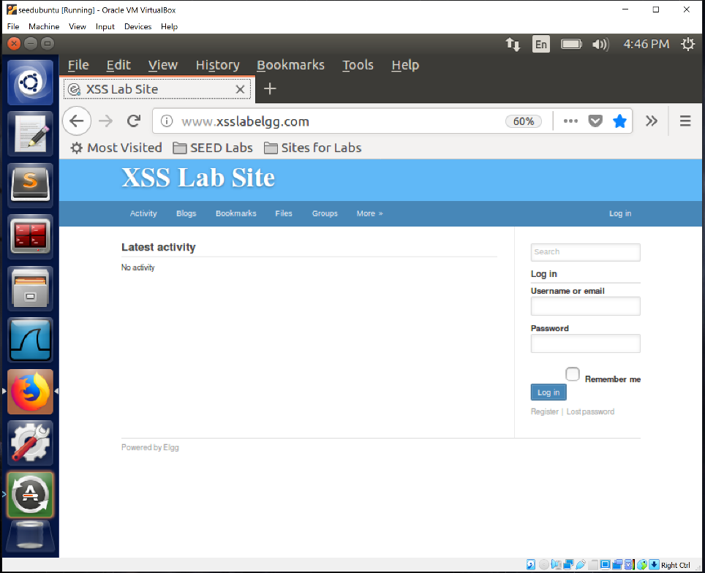

**Task 1: Posting a Malicious Message to Display an Alert Window**

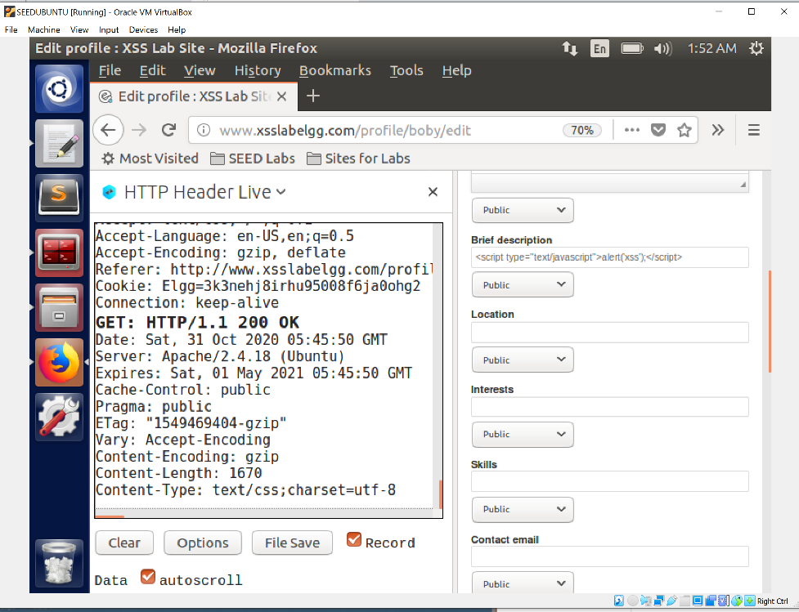

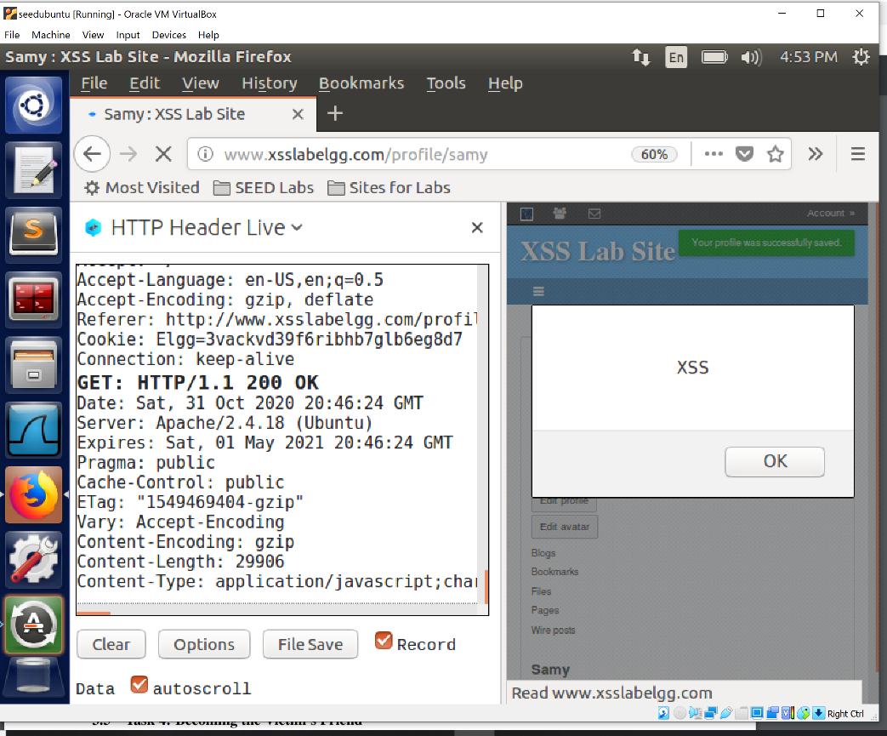

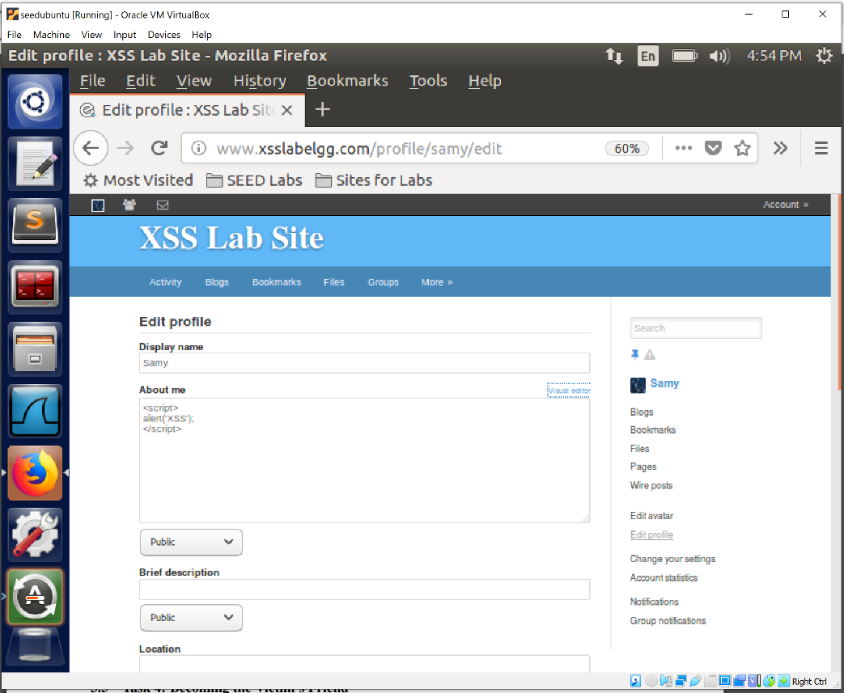

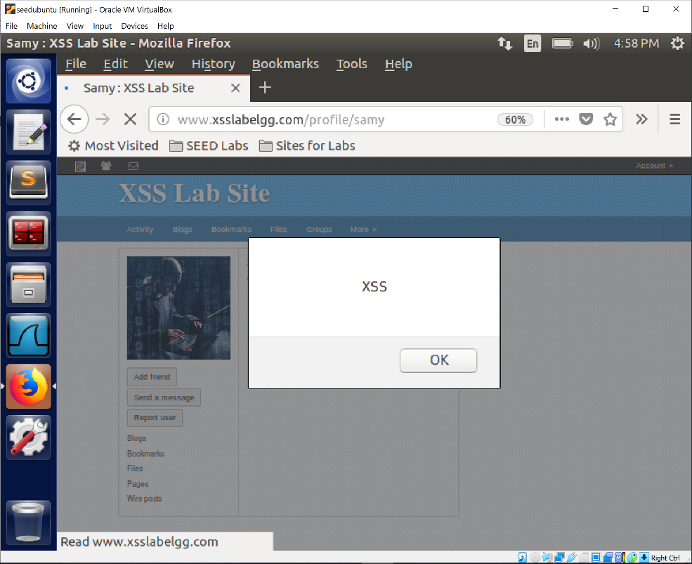

In this task we make the alert window display a malicious message. We place the javascript code in the brief description/about of the attacker. Anyone who visited this page including the attacker himself will receive the alert window pop up. This is because java script codes are executed before the page codes Every time someone visits the particular page

**Task 2: Posting a Malicious Message to Display Cookies**

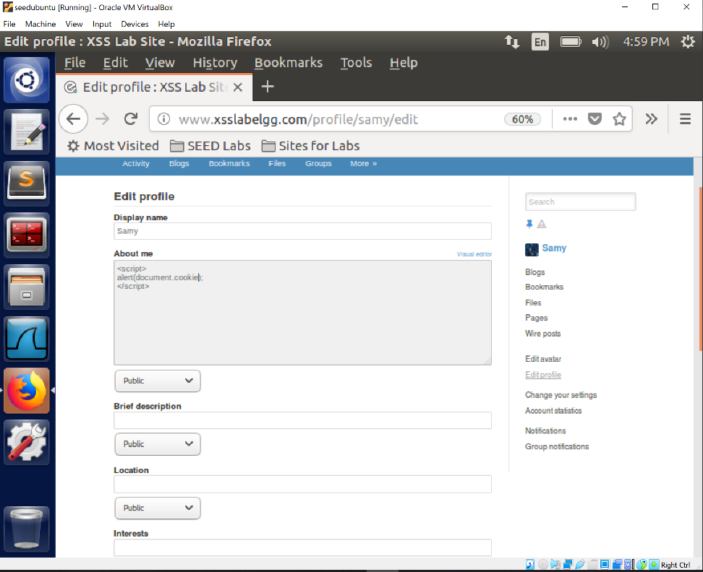

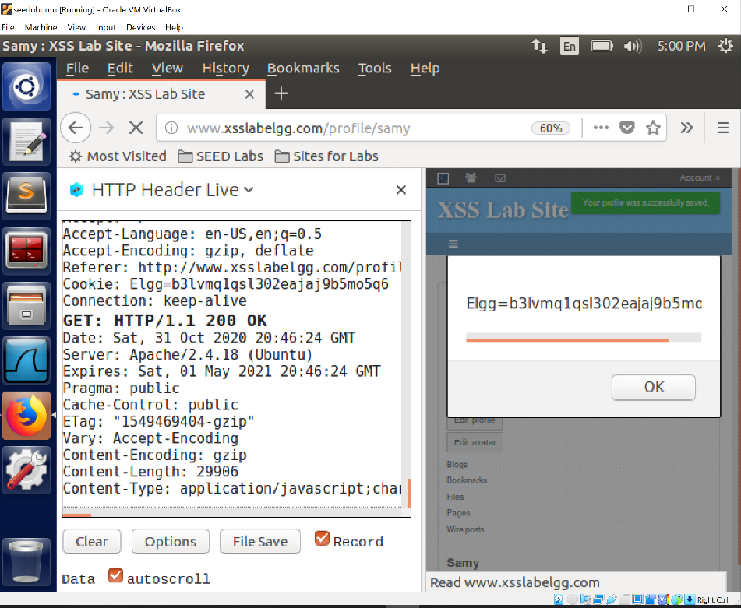

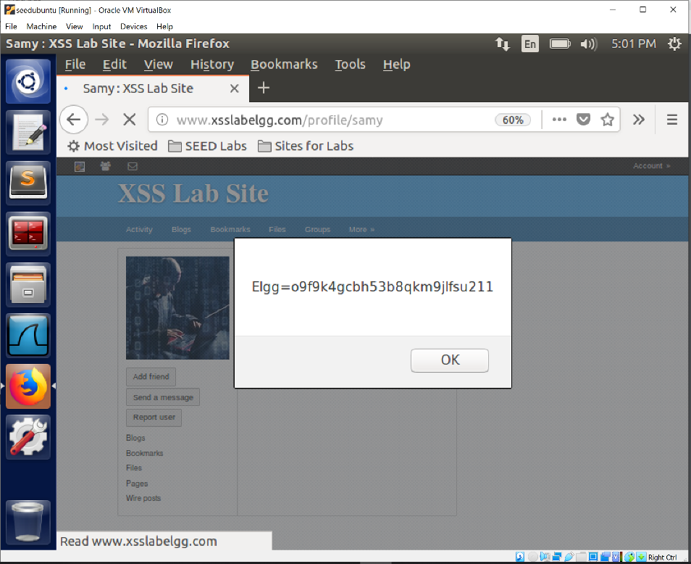

In this task we make the alert window display a cookie. We place the javascript code in the brief description/about of the attacker. Anyone who visited this page including the attacker himself will receive the alert window pop up. This is because java script codes are executed before the page codes Every time someone visits the particular page

**Task 3: Stealing Cookies from the Victim’s Machine**

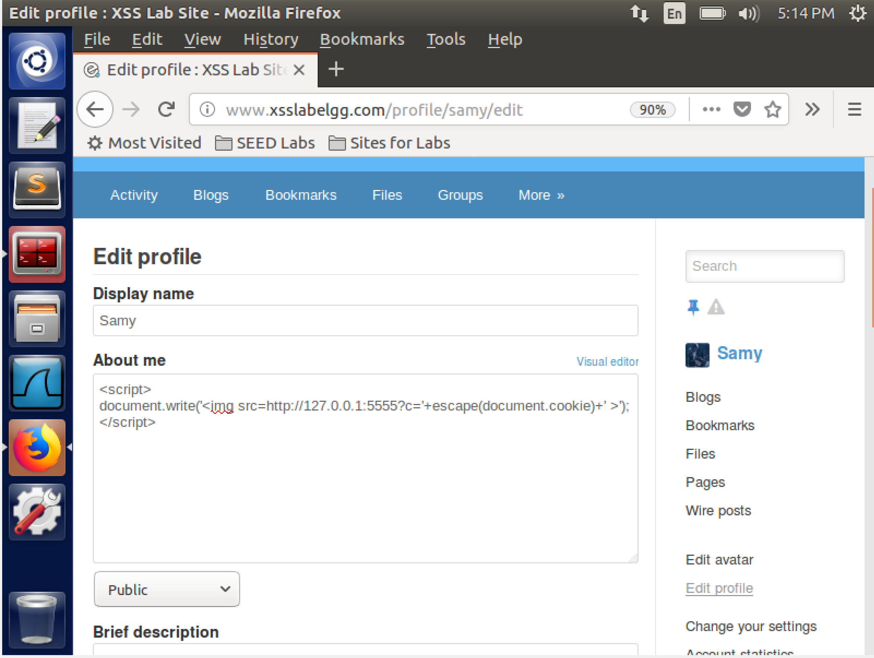

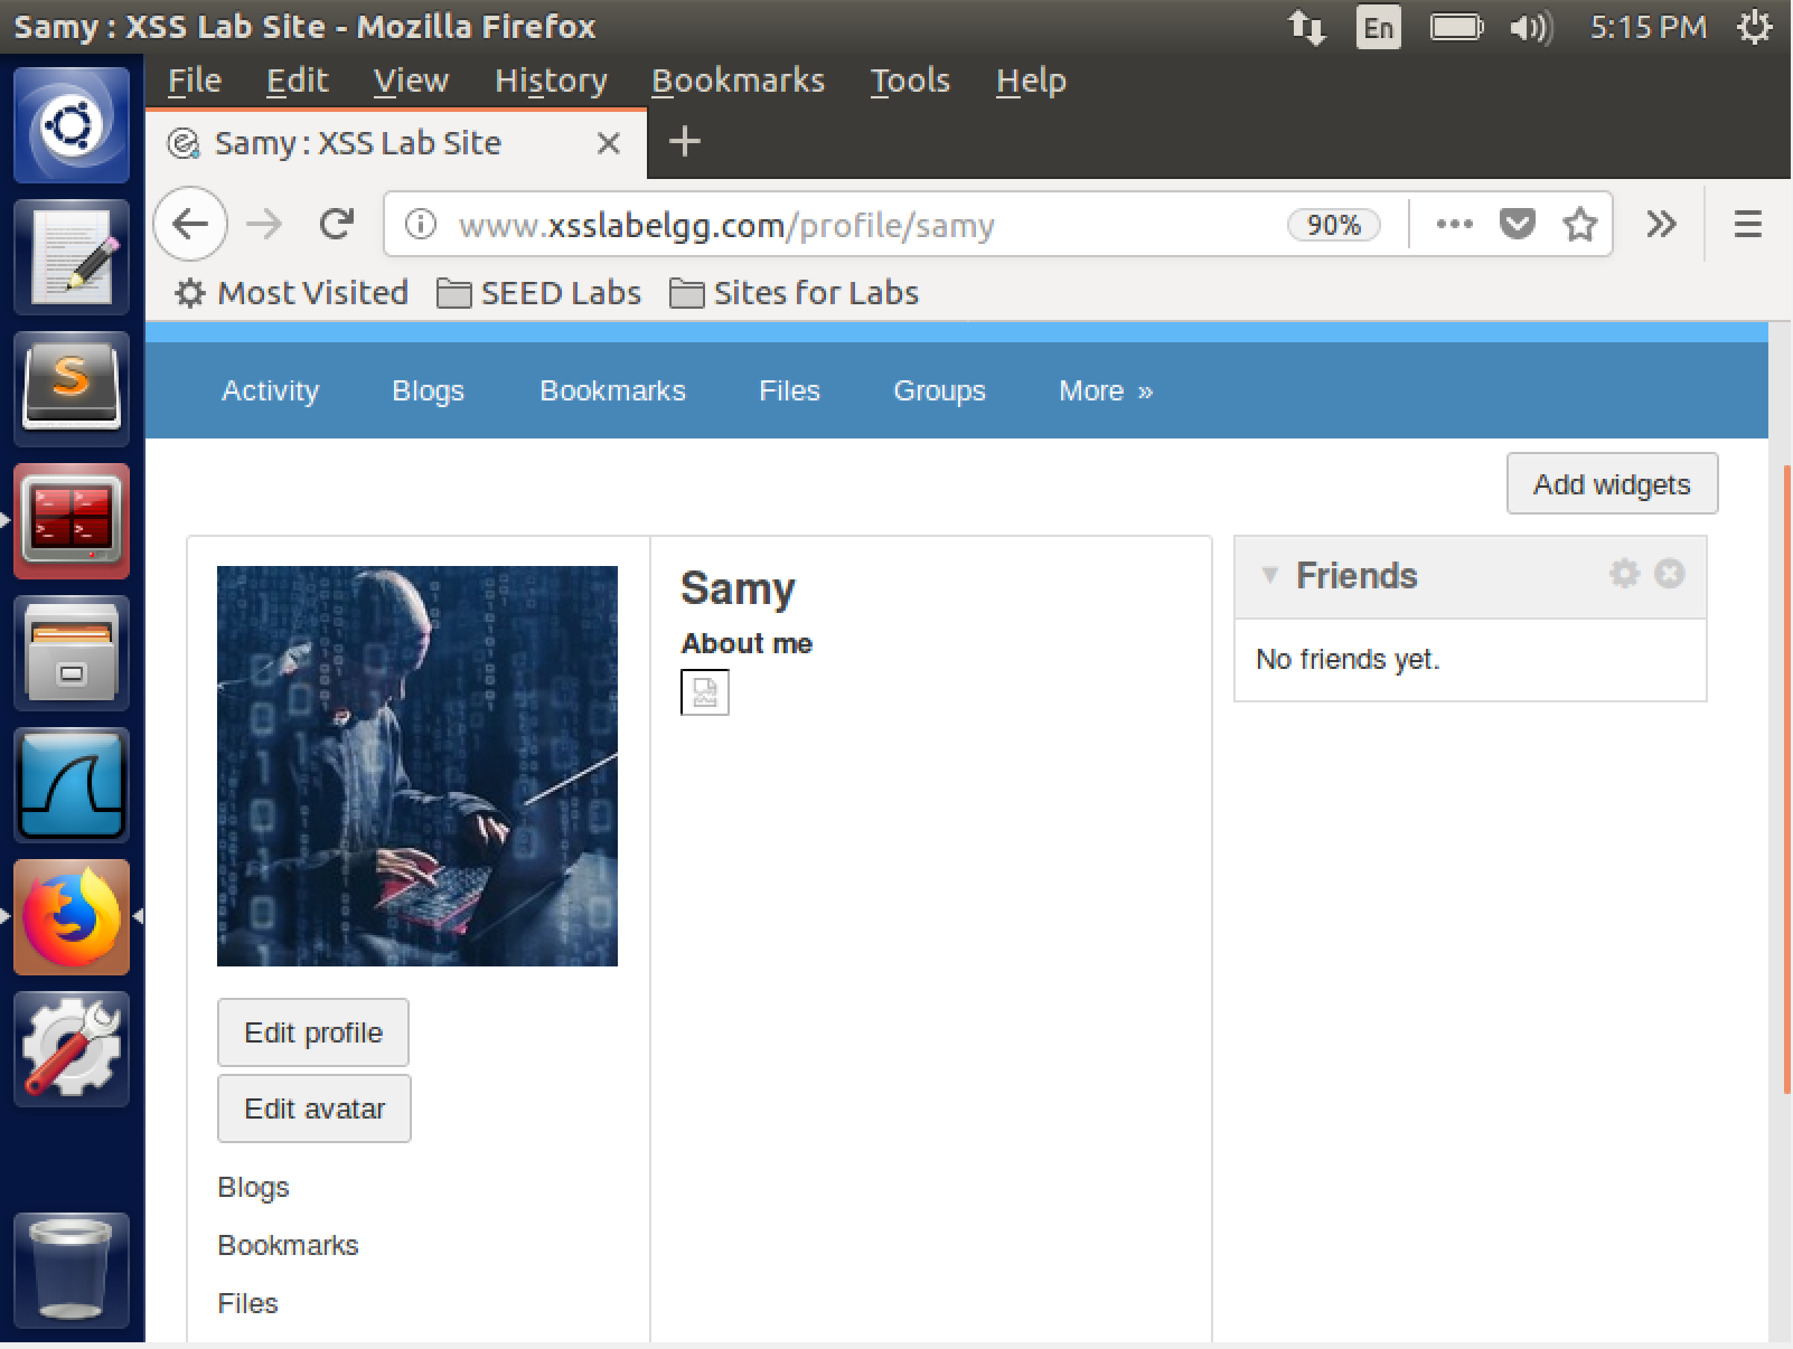

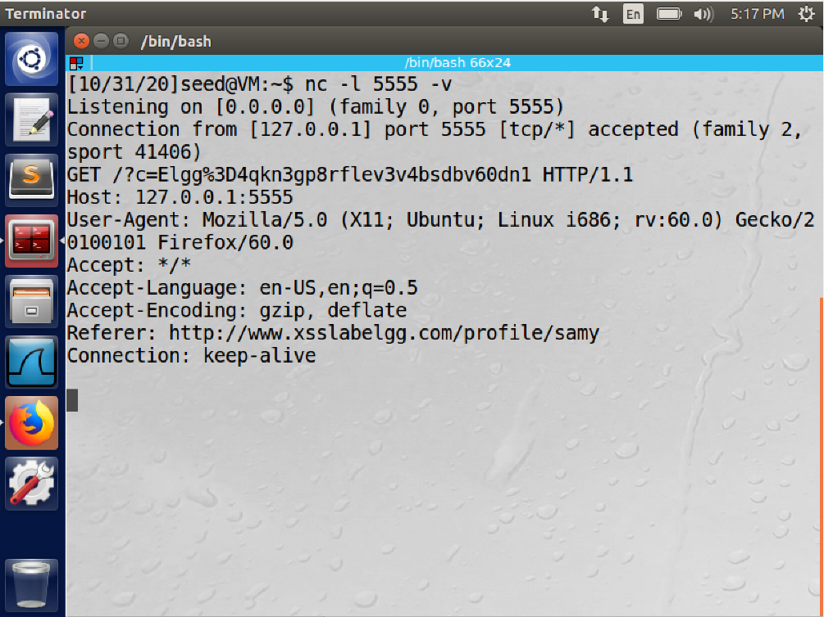

In this task we use the img tag to process and display the cookie information. In the terminal we start the server and then when a user visits the attackers profile we get the cookie information on the terminal.

**Task 4: Becoming the Victim’s Friend**

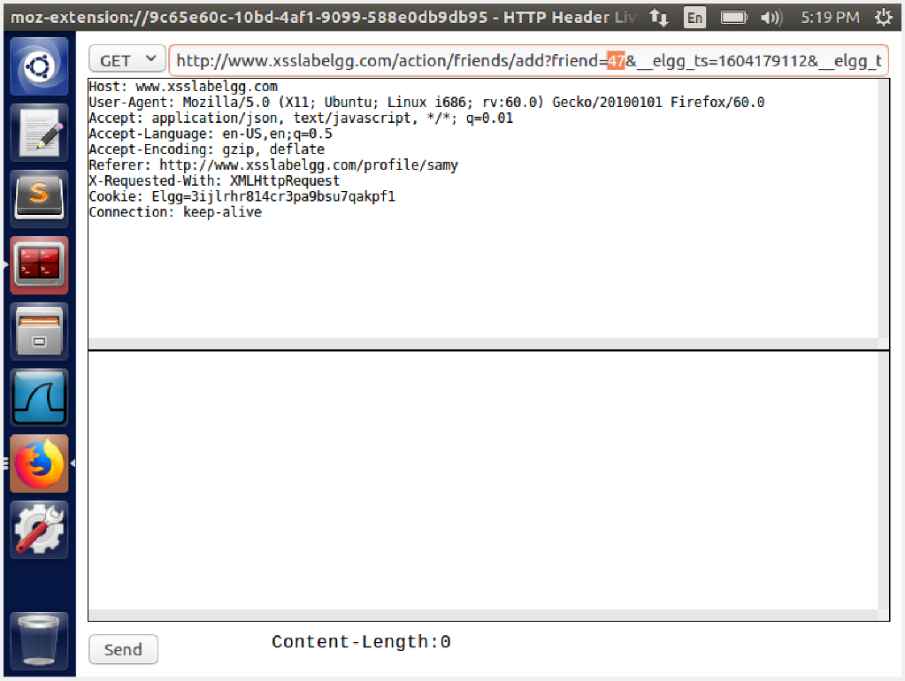

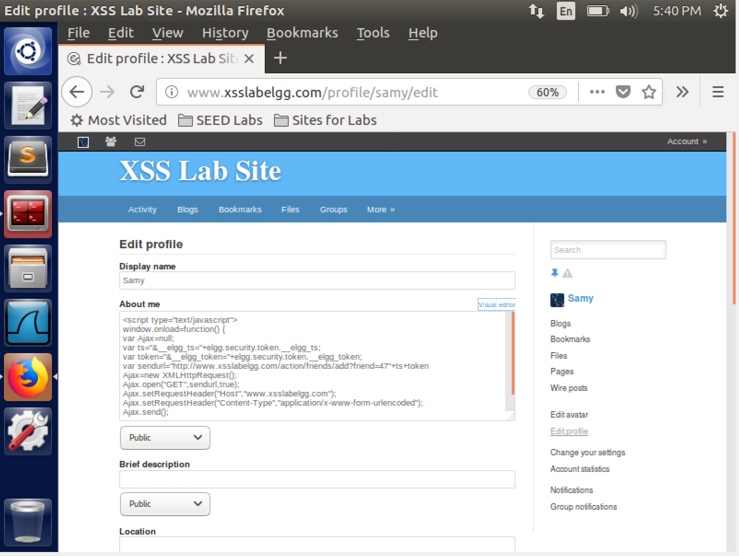

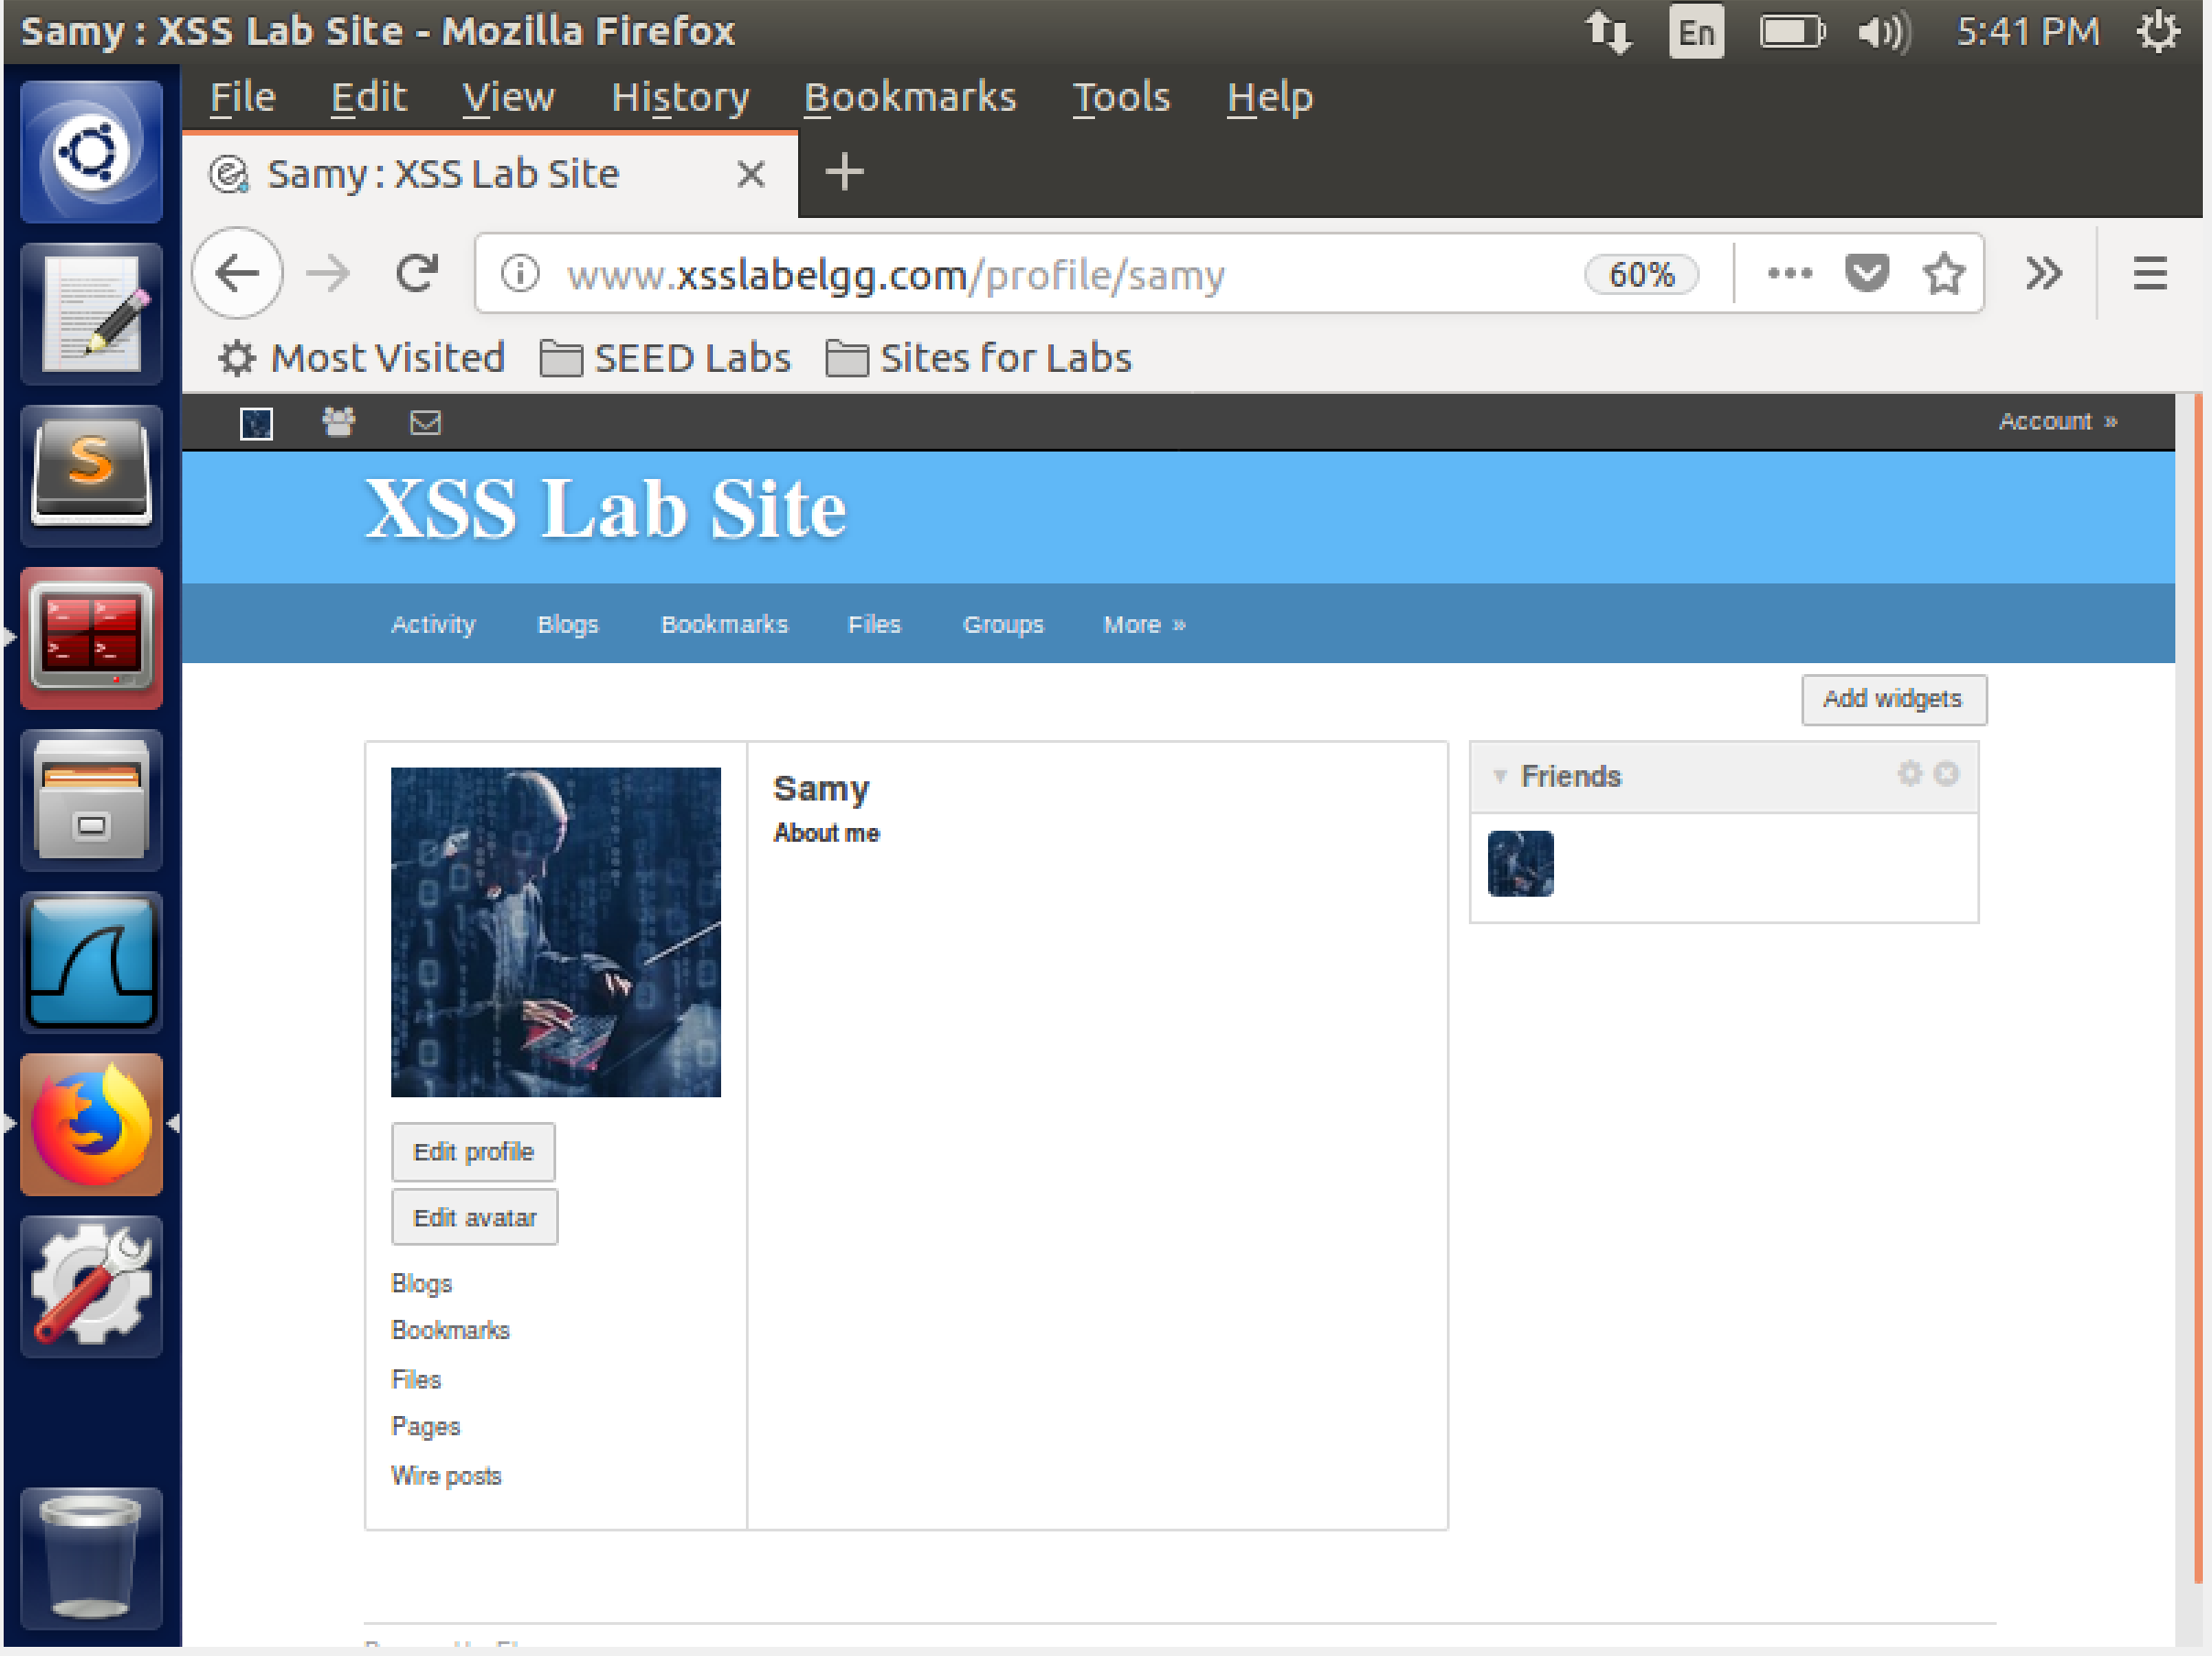

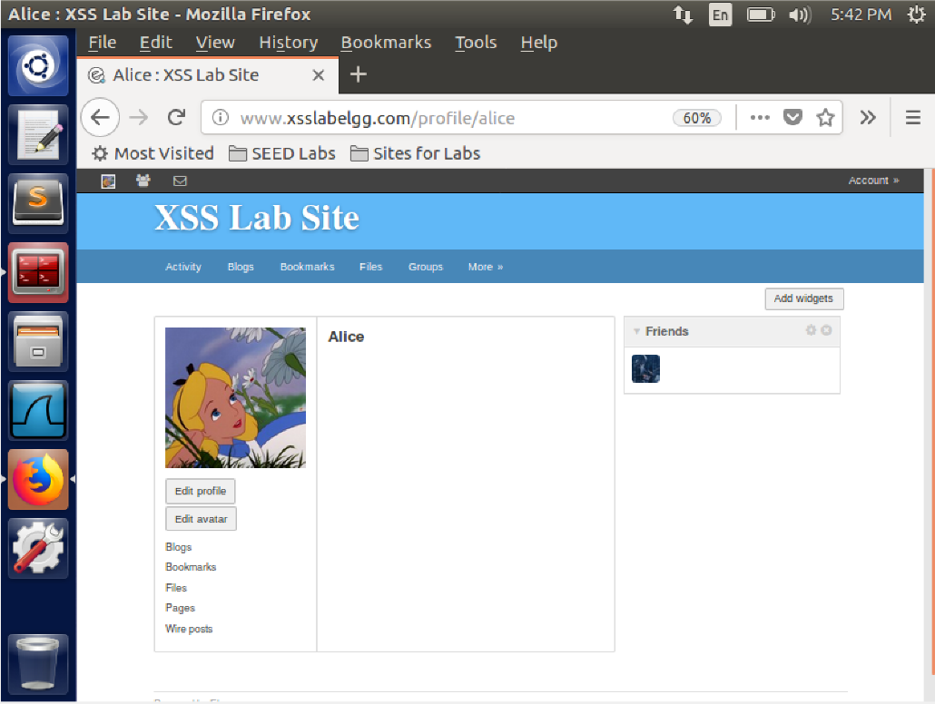

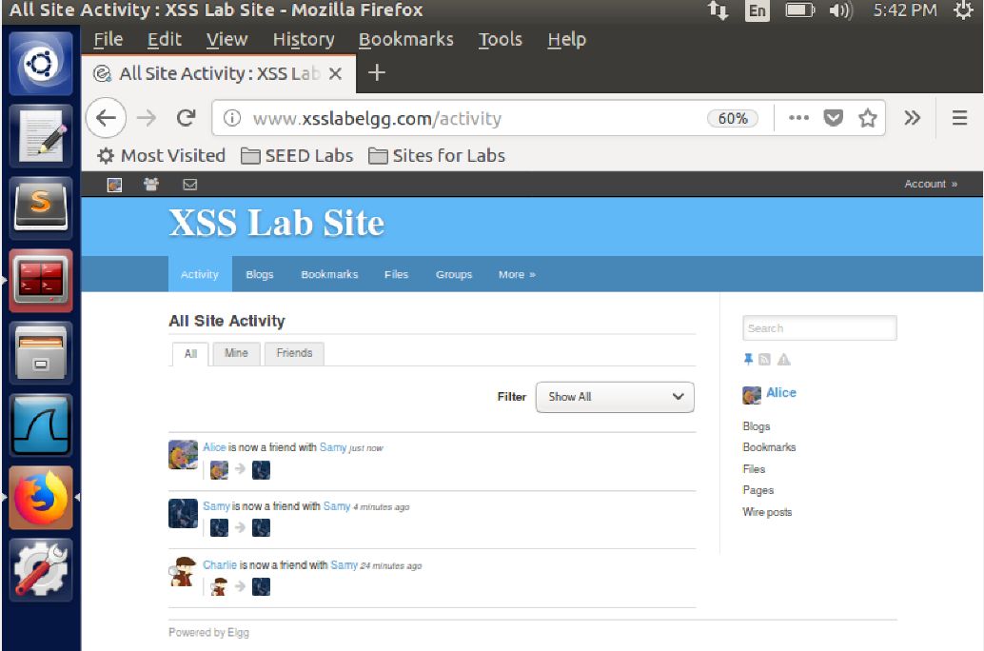

In this task we create a script where whoever that visits the attackers page are automatically added as their friend.First we get the http get packet to get the add friend url and the GUID of sammy. We place this in the about section of sammy's profile. On saving we see that sammy is added as his own friend. We then visit sammy's profile from Alice's profile. We see that alice is added as sammy's friend. We have used the GUID , add friend information and tokens to forge a false GET request.

**Question 1)** Lines 1 and 2 get the timestamp information and token data from the victim to forge a GET request

**Question 2)** if the elgg only provides editor mode then we would get our malicious code placed between <p> tags.this will result in our code being displayed in the about section and not being executed as intended.

**Task 5: Modifying the Victim’s Profile**

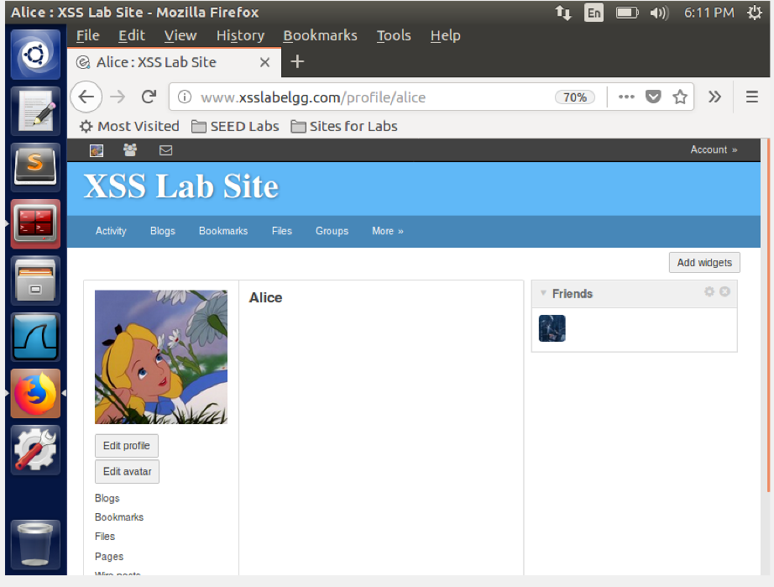

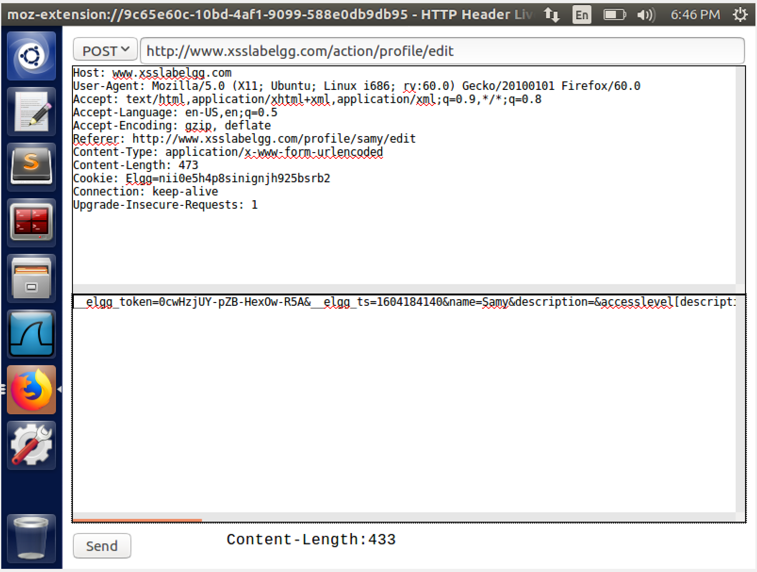

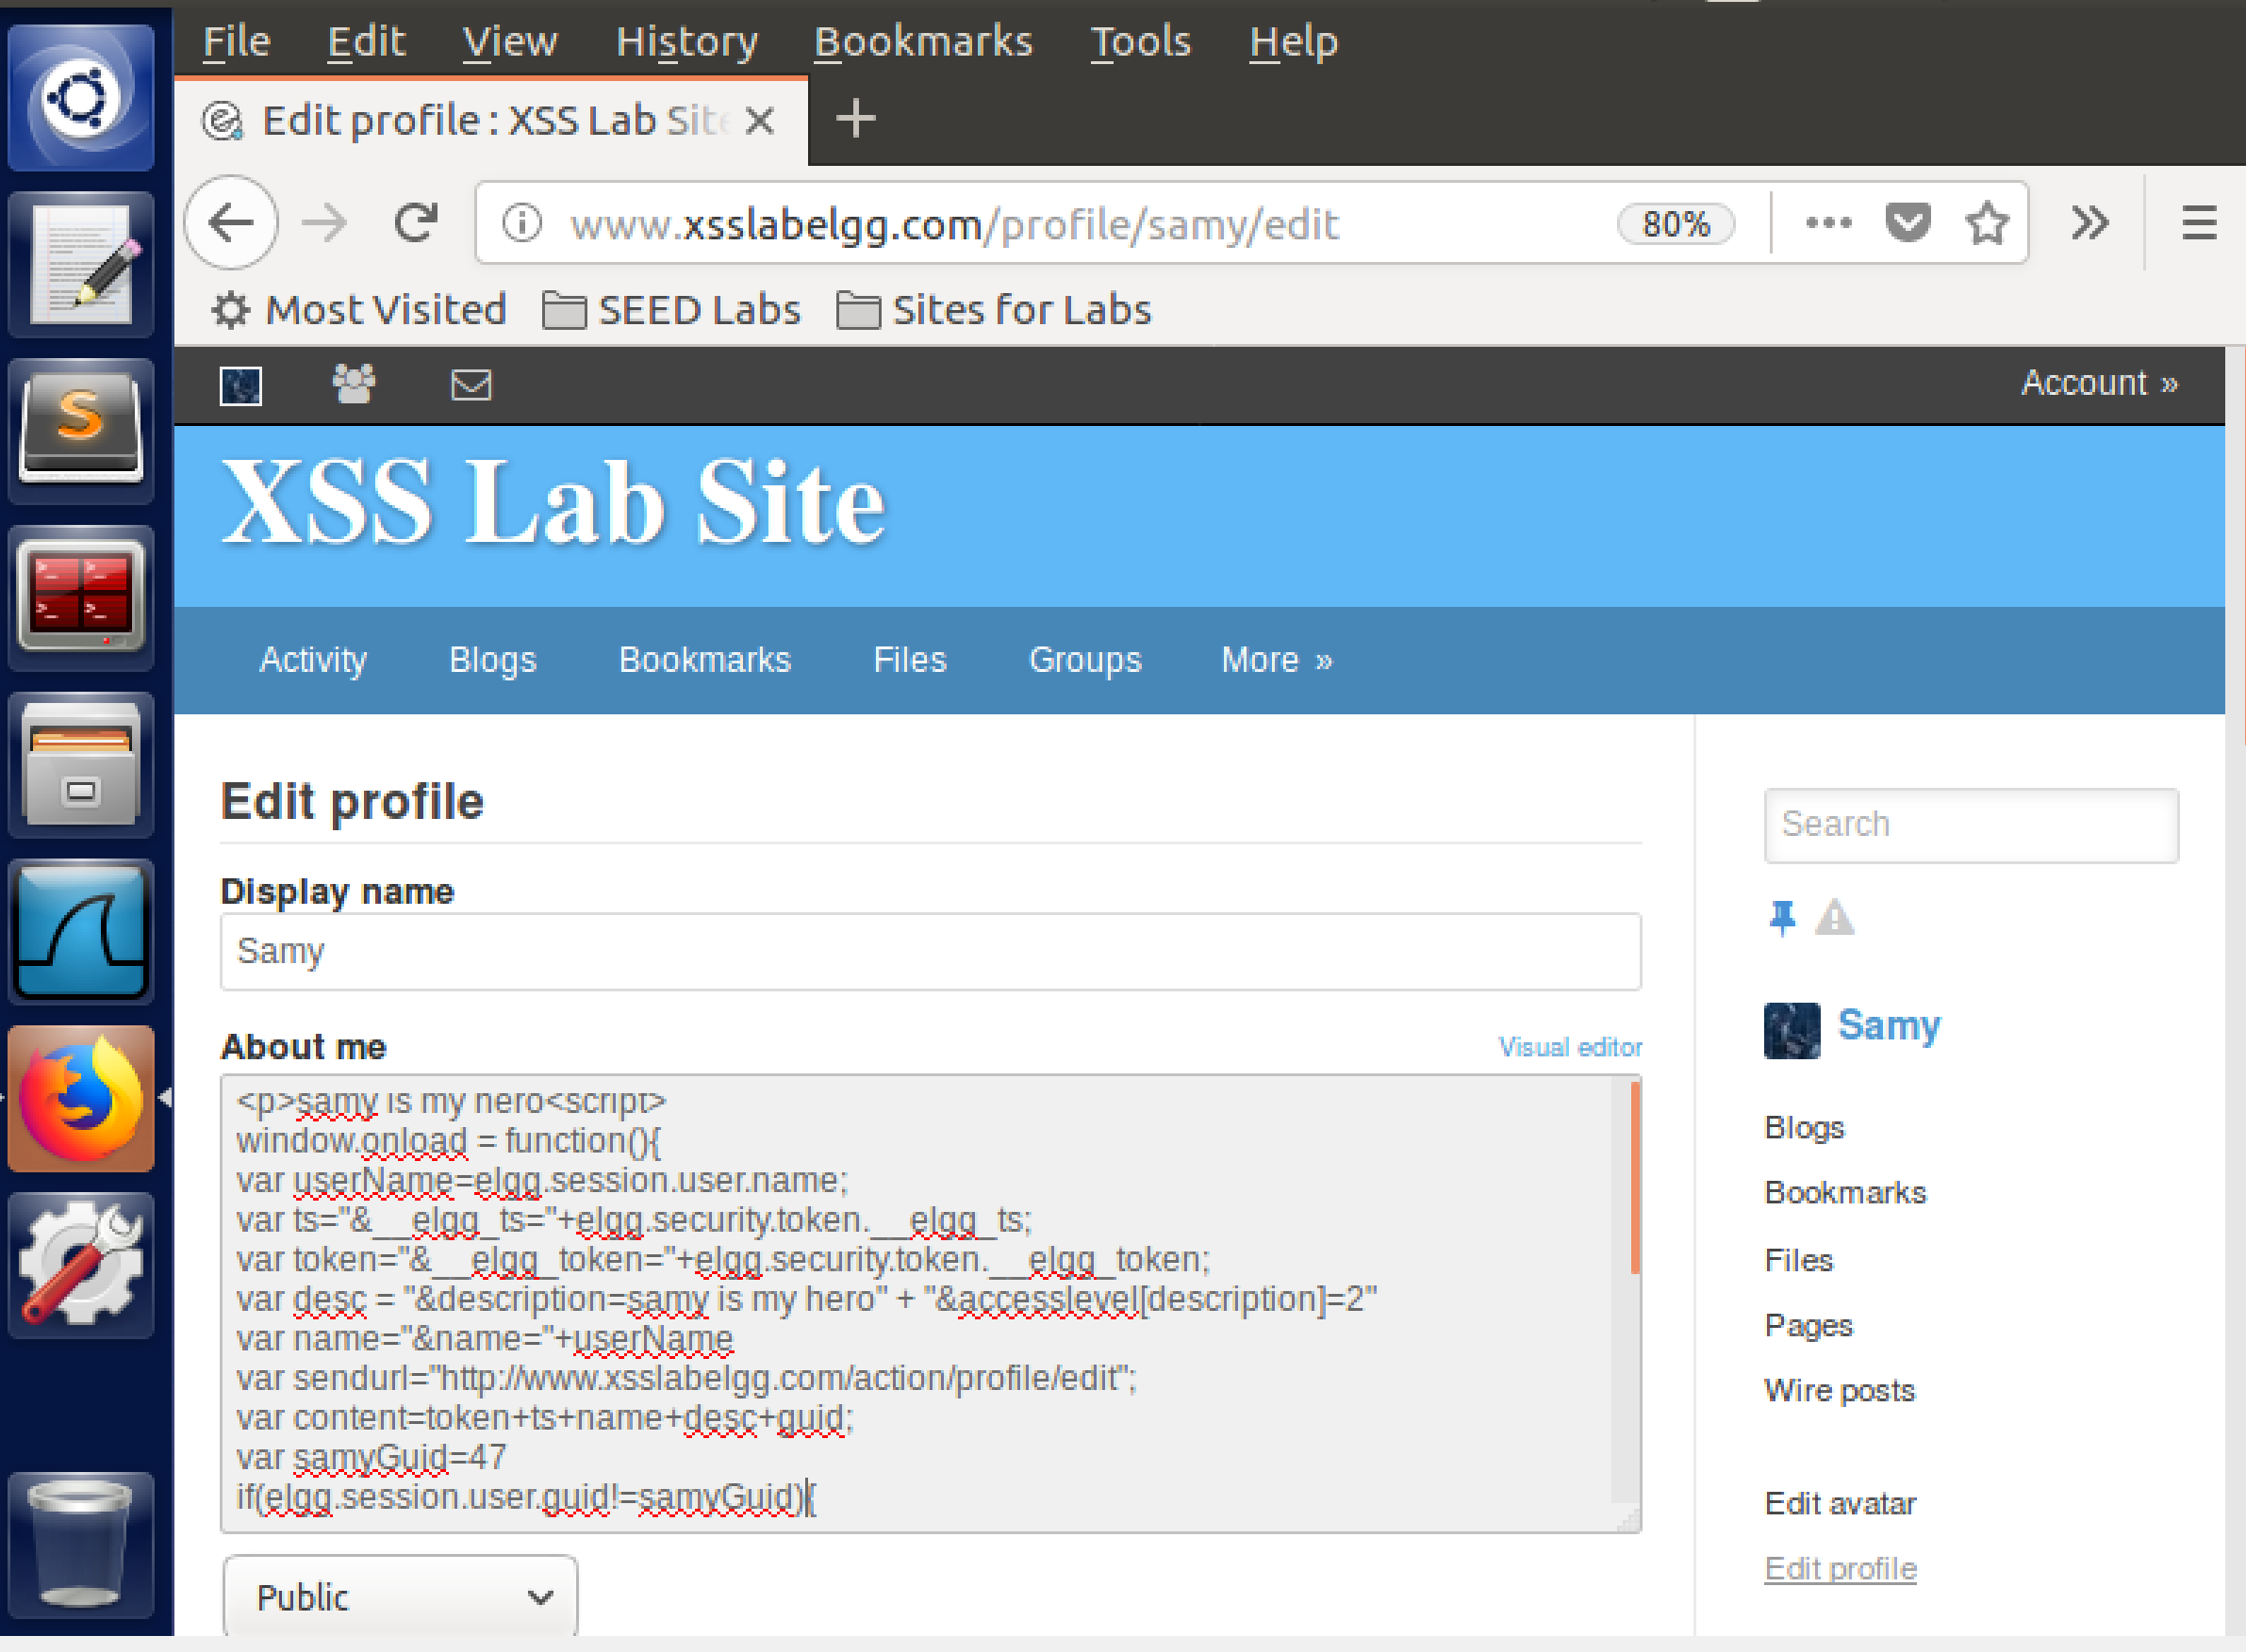

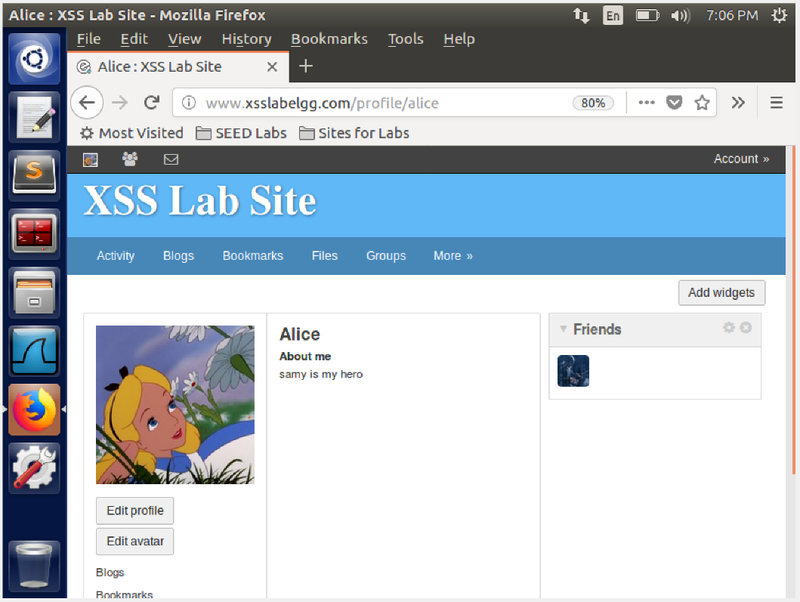

In this task we create a script that modifies the victims profile when they visit sammy's profile. First we capture the post request for changing the profile using HTTP header live to get the url for the post requests. We then place the script on the about section of sammy's profile. We visit the profile from Alice's profile and we see that the about section of Alice's profile is edited as well. This is because we have used the token information,Sammy's GUID, and forge a false POST request. This we can edit the victims profile as seen successfully

**Question 3)** line 1 checks if sammy is the one visiting his own profile, if so then do not edit the profile. Now removing the line 1 will result in sammy editing his own profile

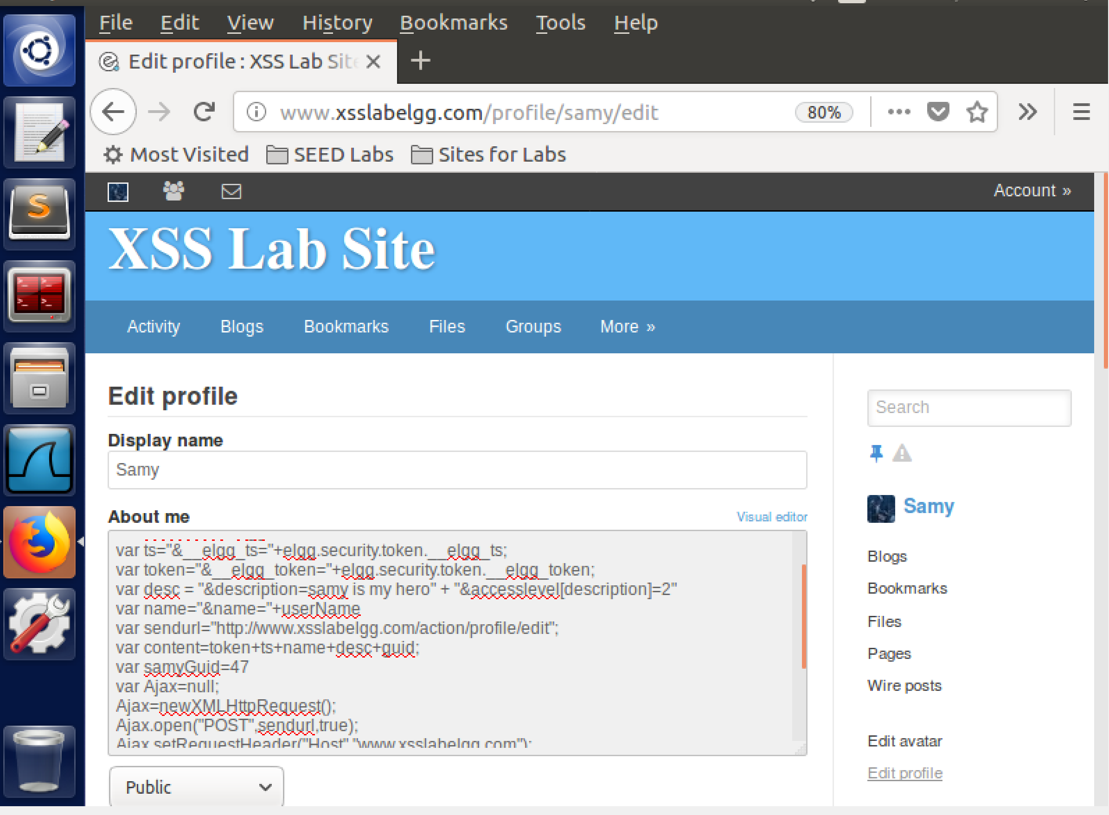

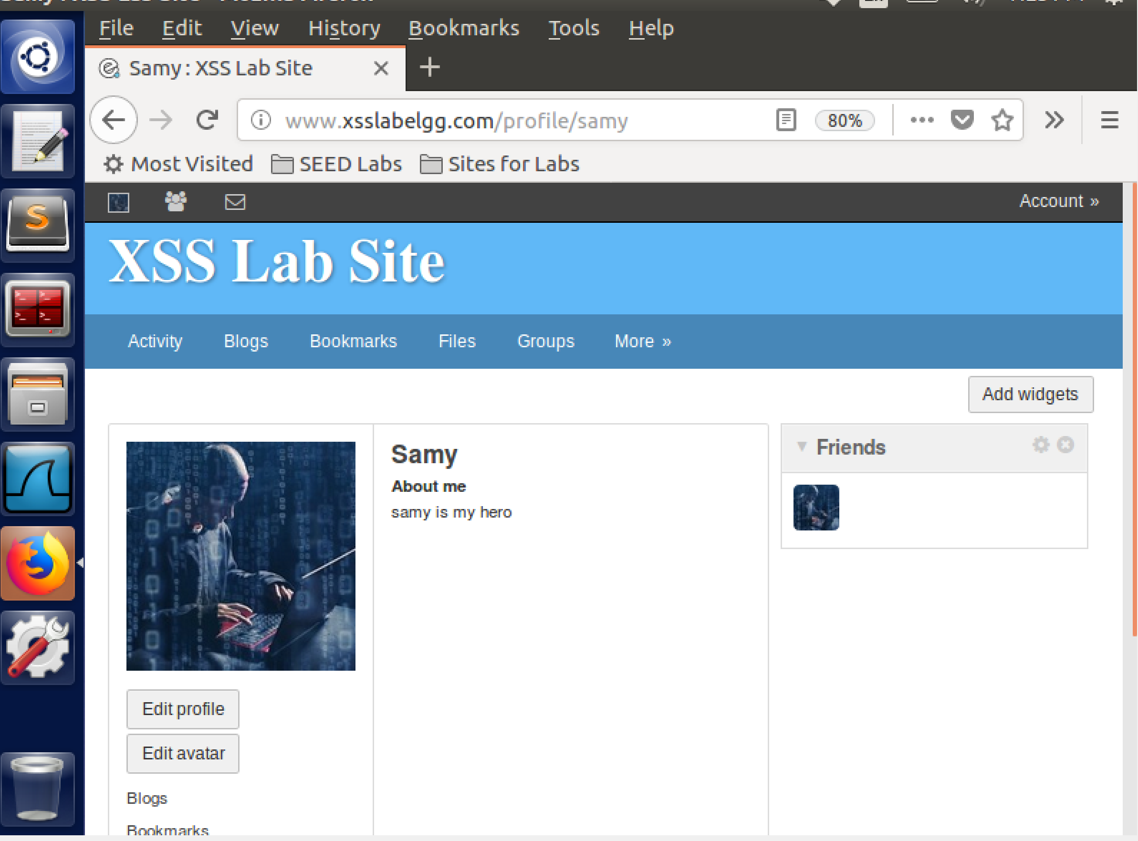

**Task 6: Writing a Self-Propagating XSS Worm**

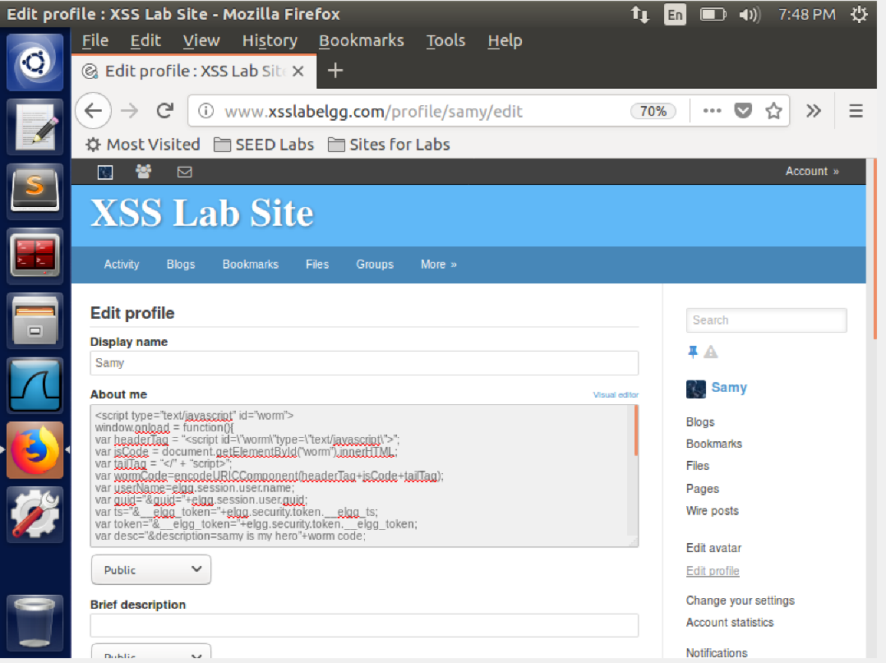

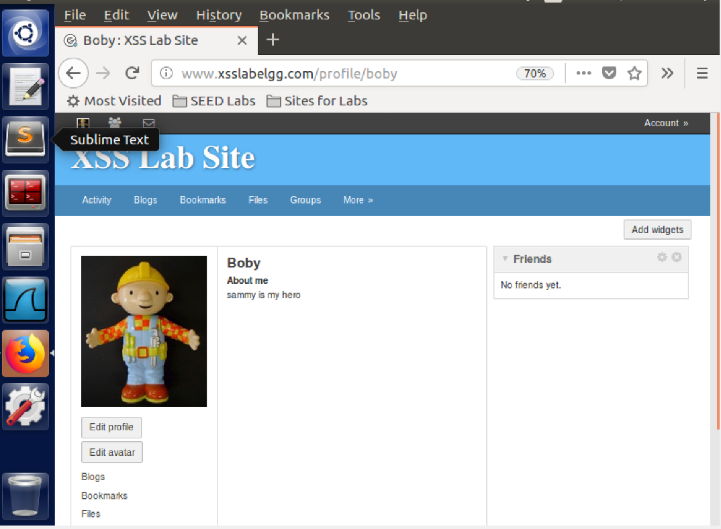

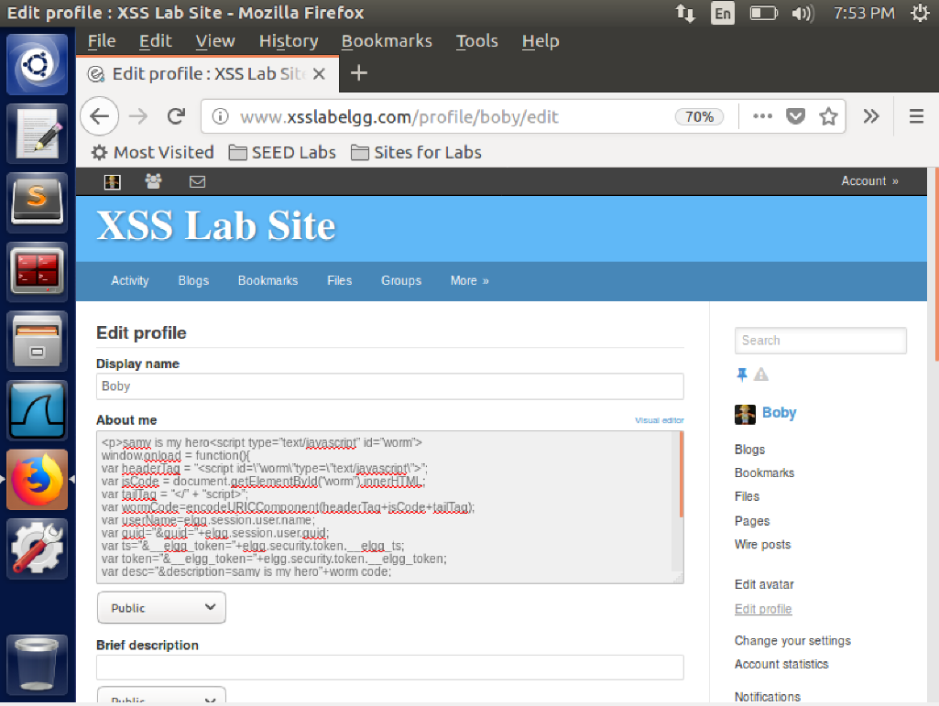

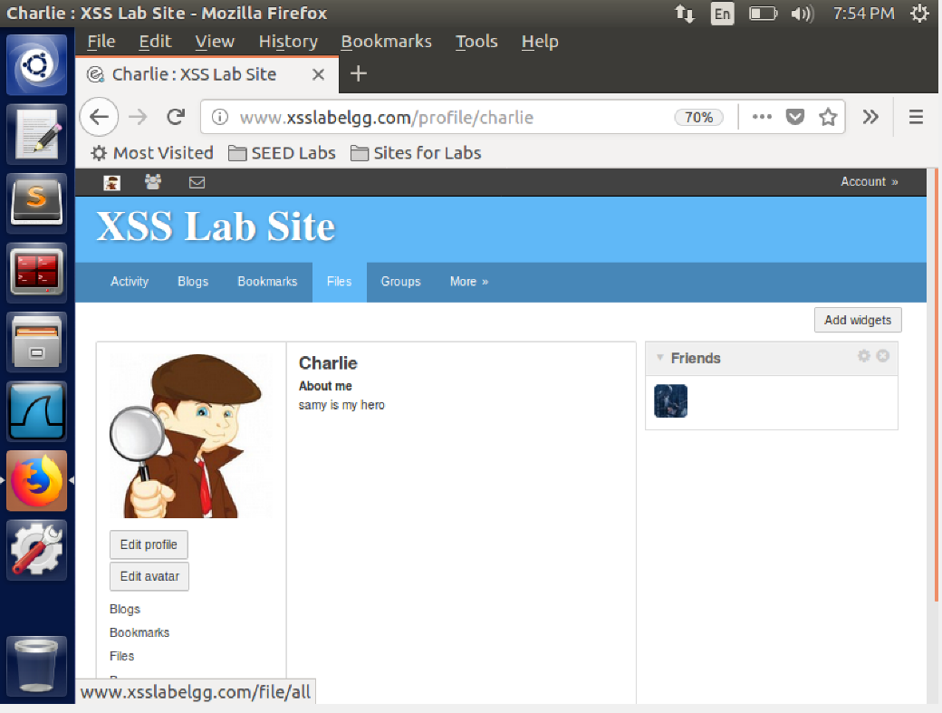

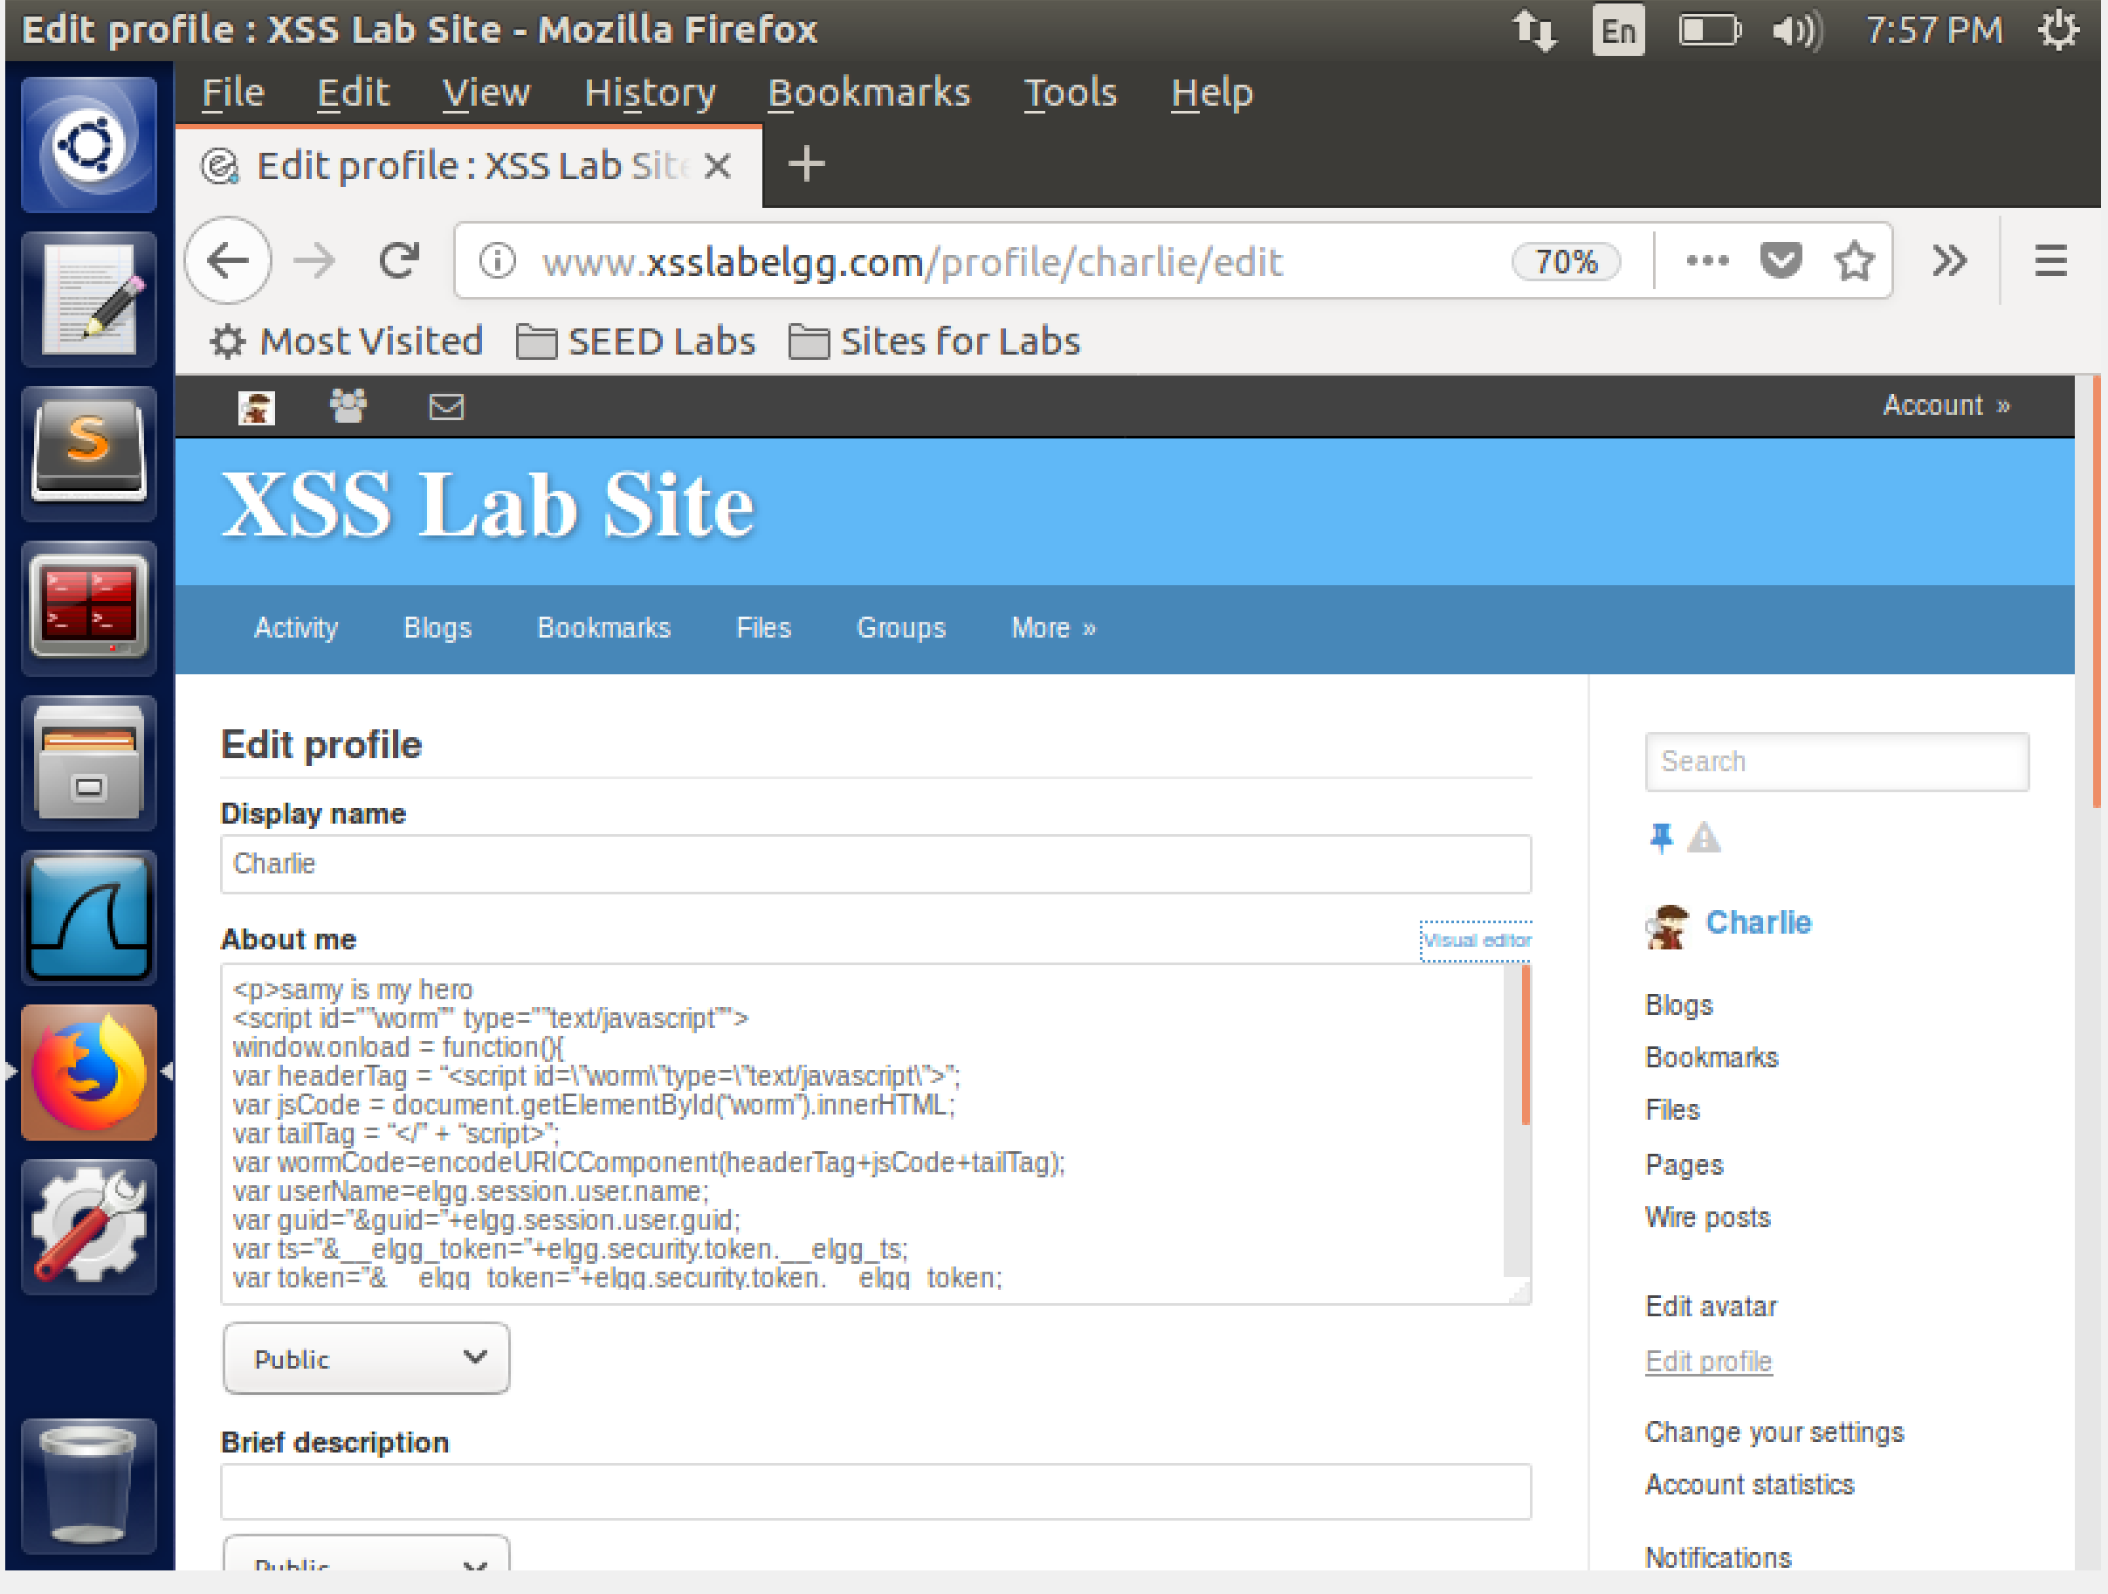

In this task we aim to create a script that edits a users profile and make it propogate from one user to another. We first write a script with sammy's GUID and the edit profile link. We place the script in sammy's profile. We visit sammy's profile using Alice and charlie's profile. We see that the profiles of charlie and alice are also edited. Having a close look at one of the victims profile we see that the code has been copied to the profile of the victim. This is because the innerHTML calls the javascript function that then copies the code to the profile of the victim.

**Task 7: Countermeasures**

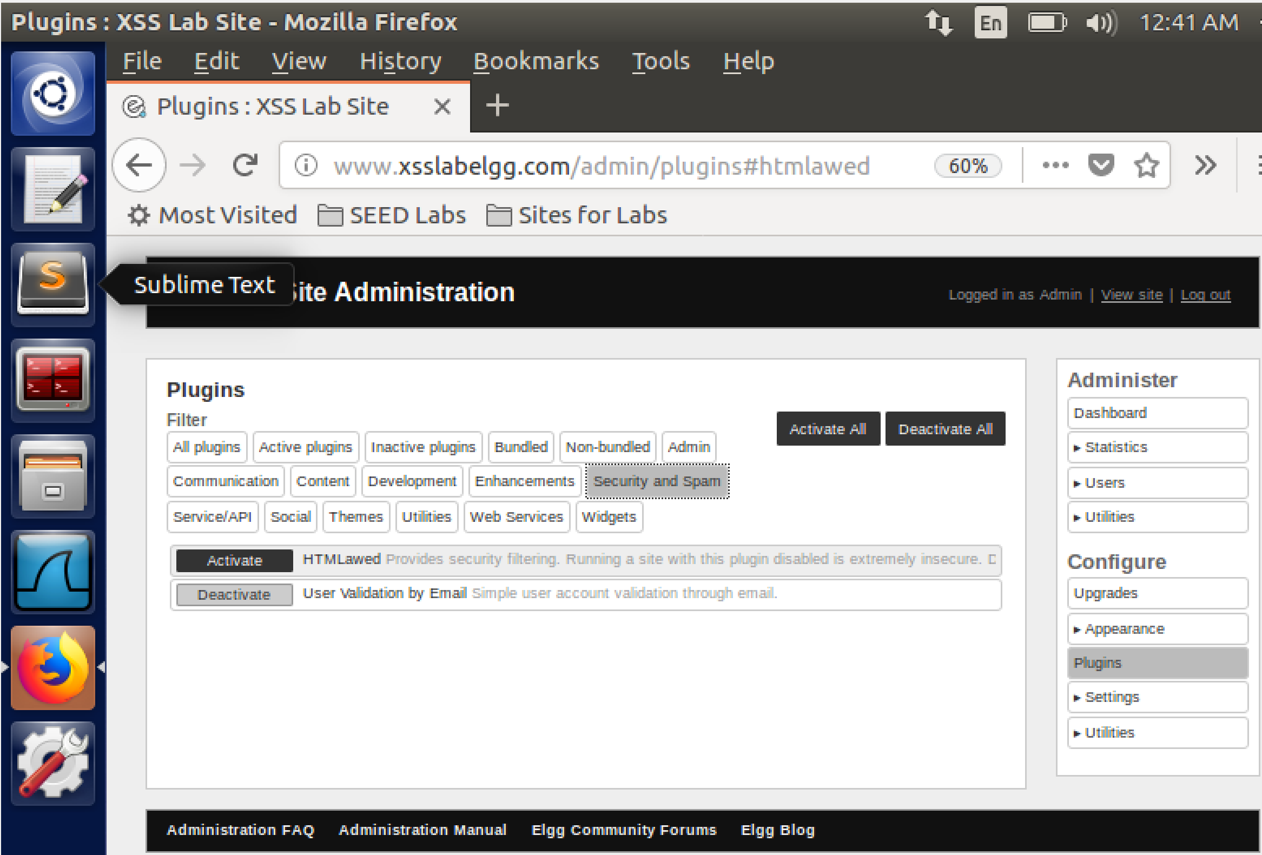

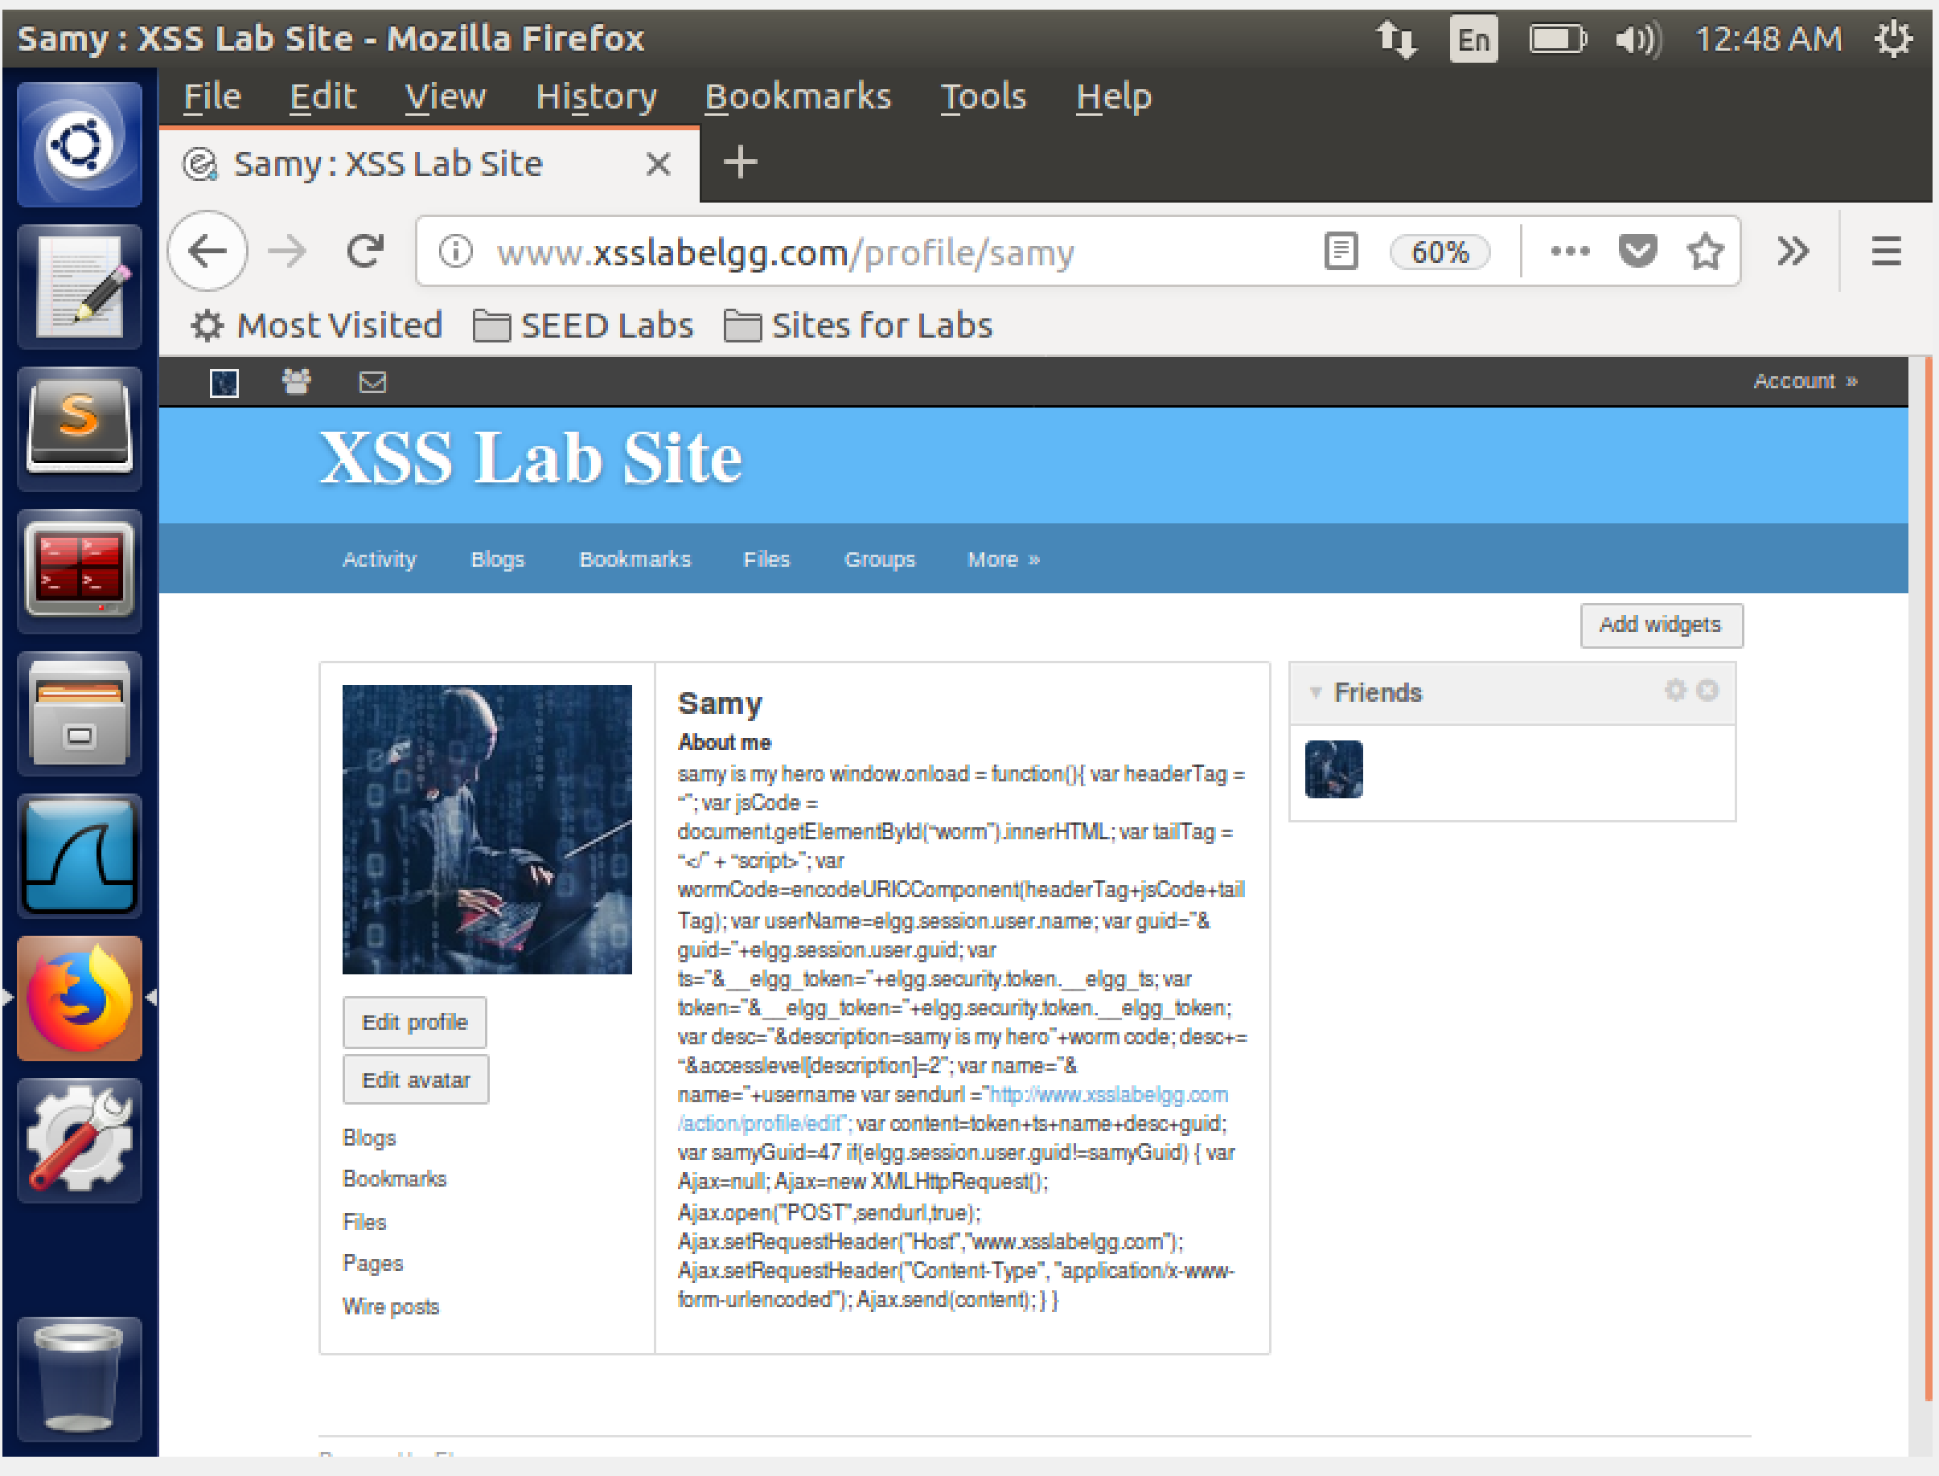

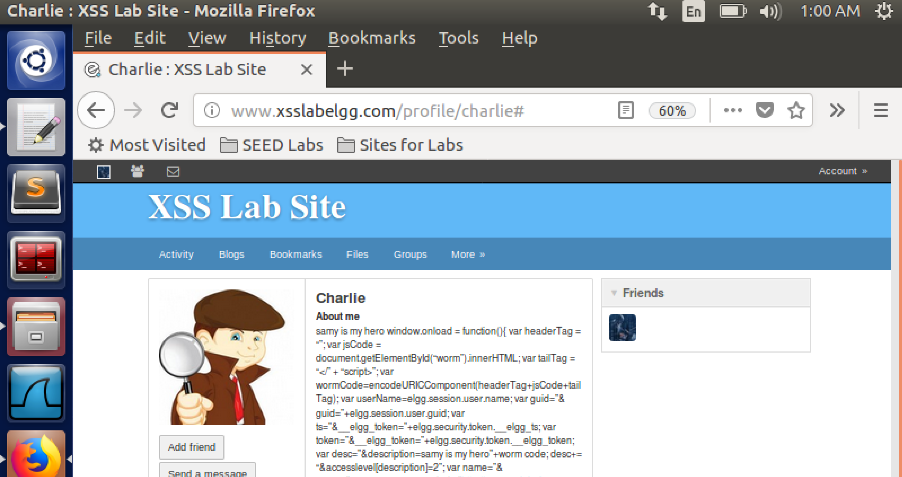

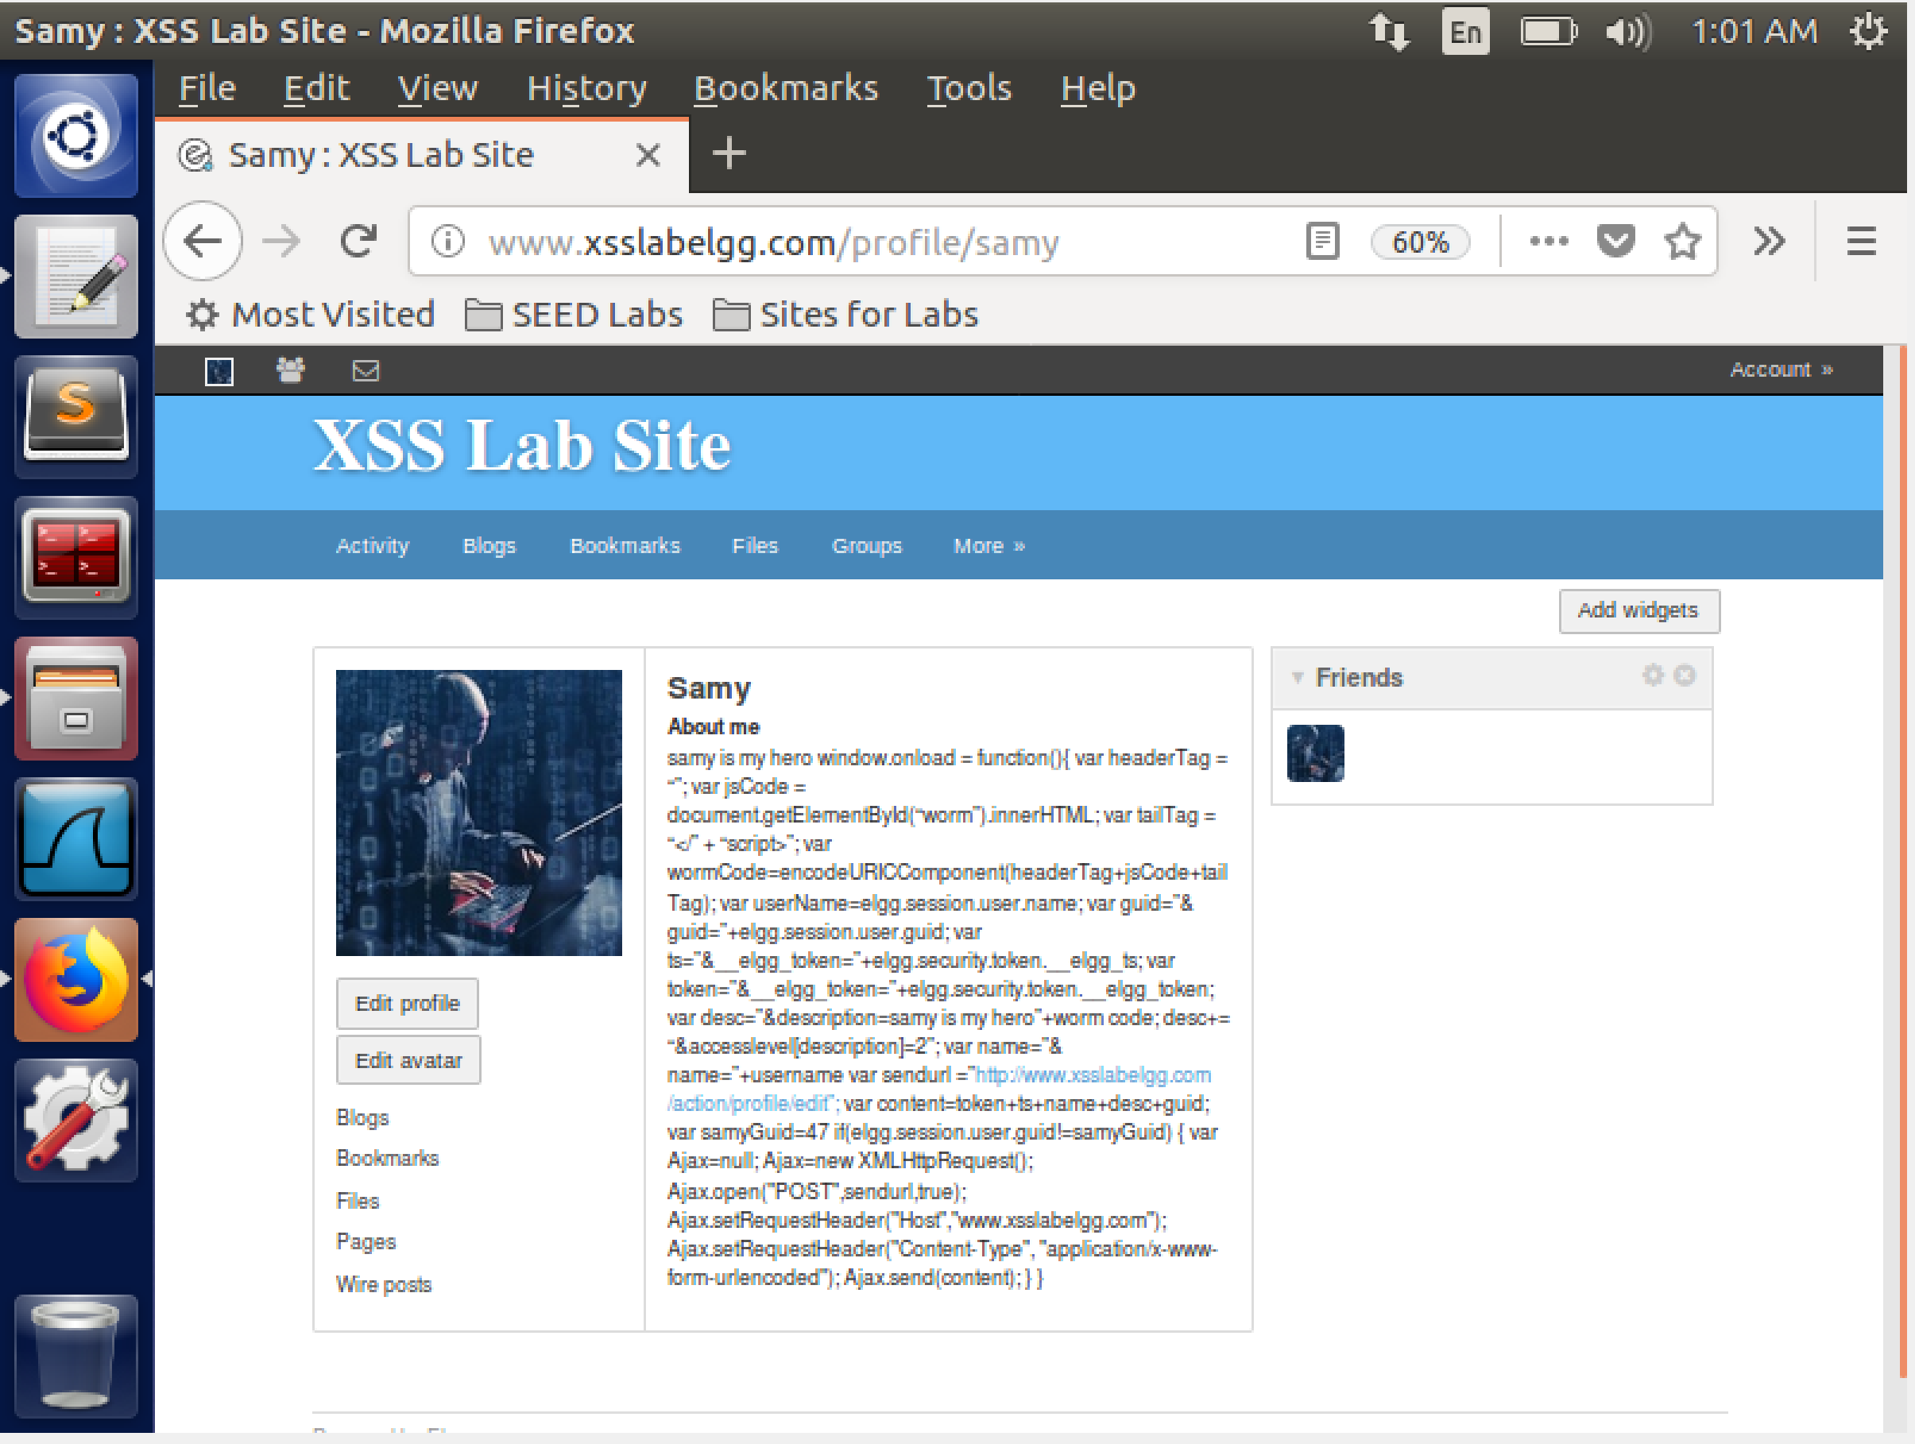

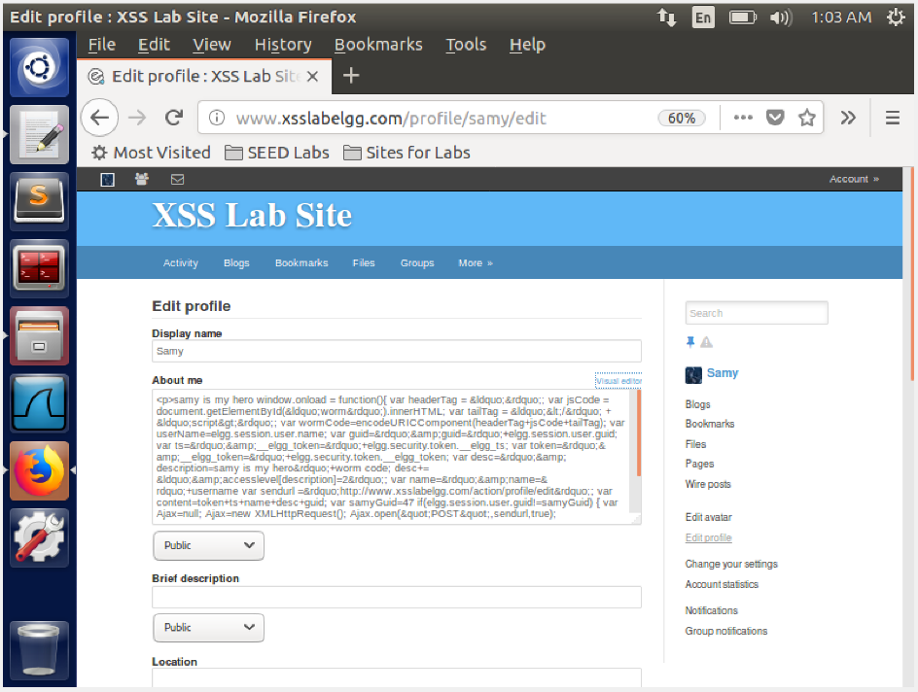

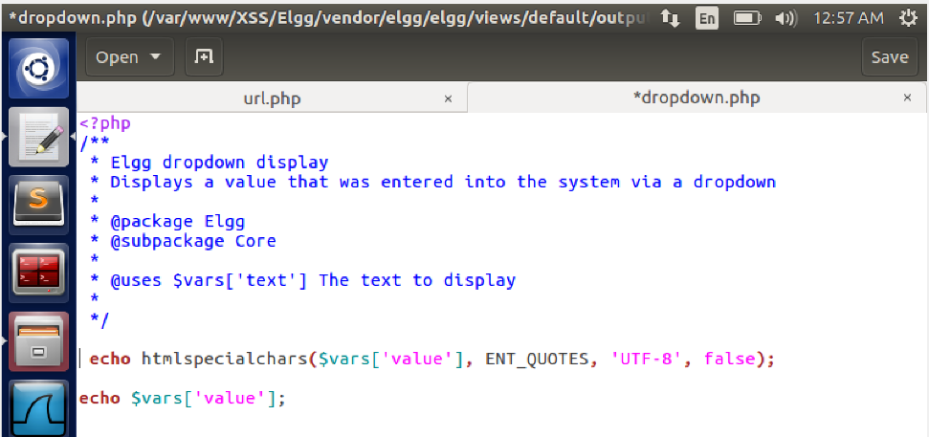

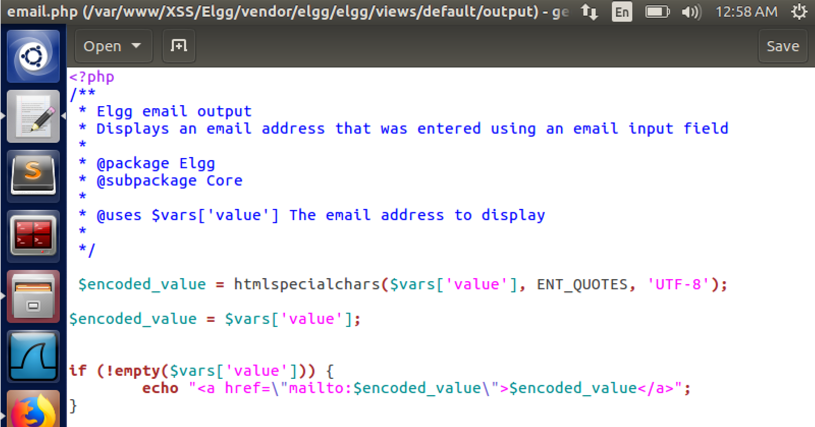

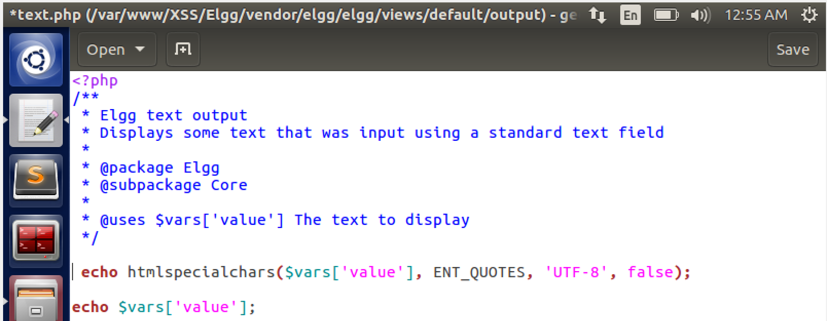

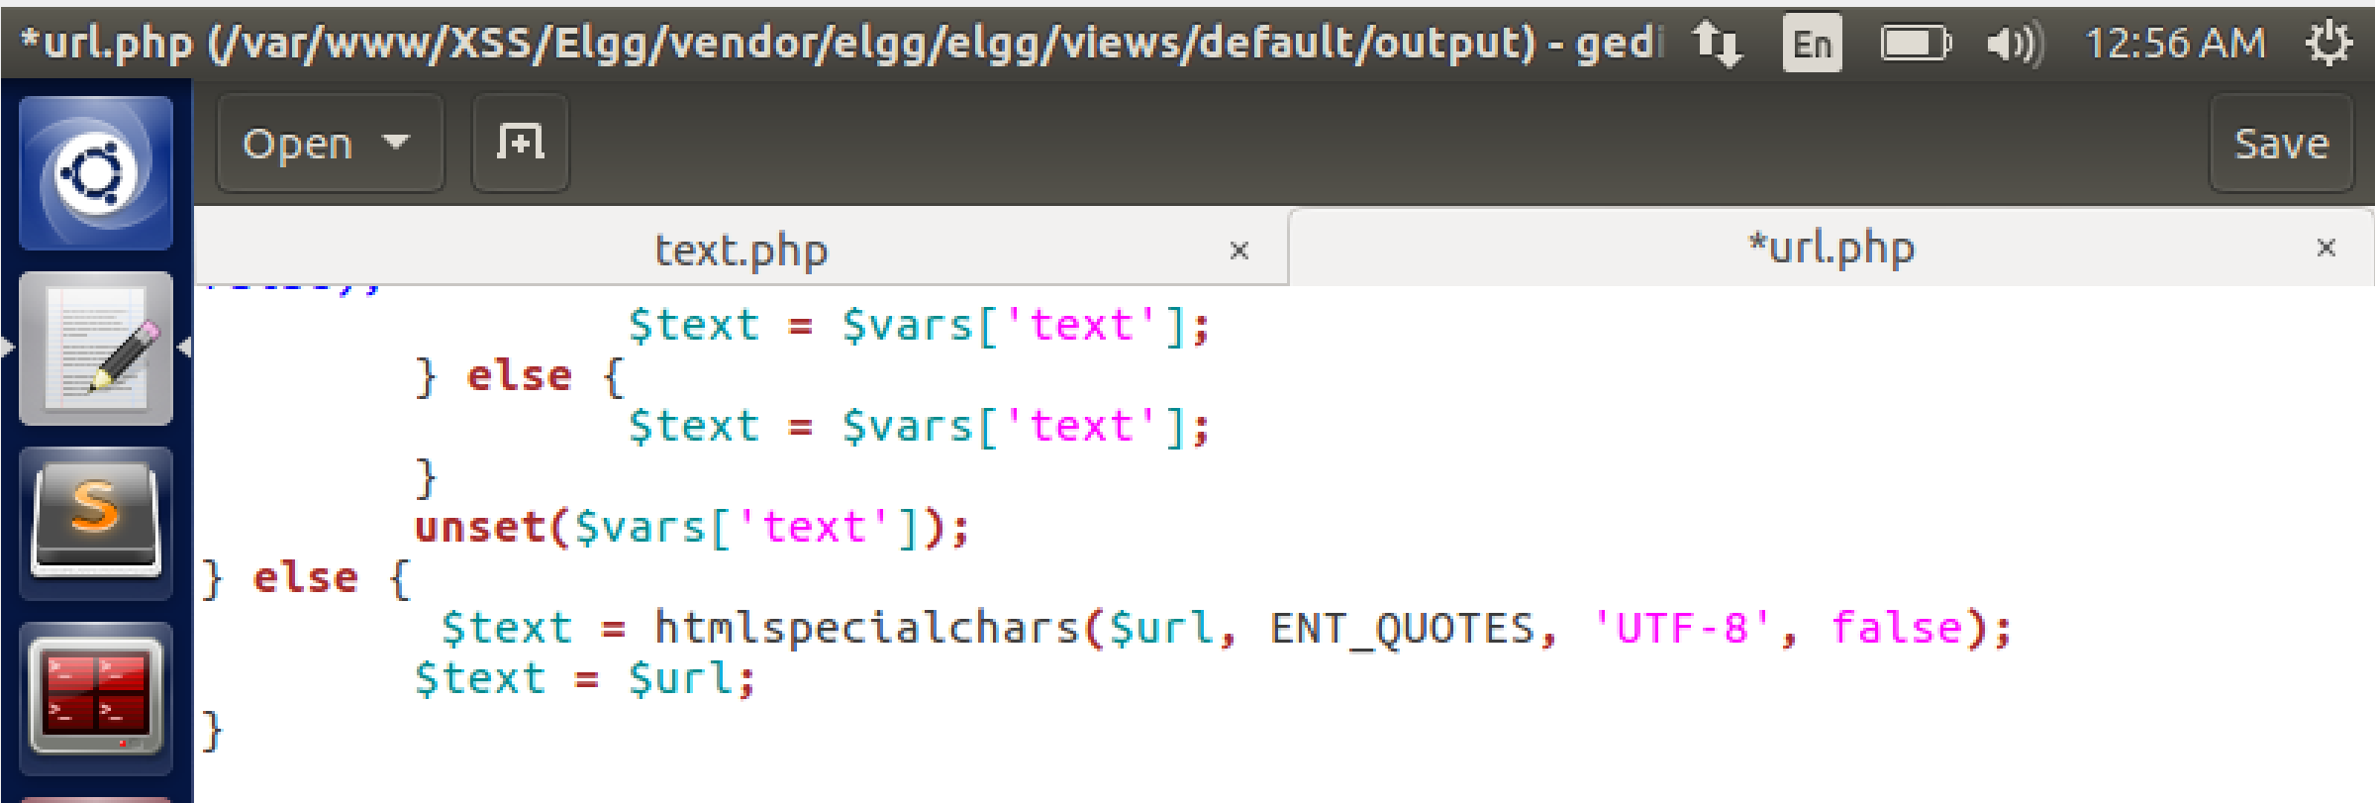

In this task we turn on the countermeasures which elgg have against XSS.

When HTMLlawed is turned on then the malicious script/code is treated as a text. We see the code bring displayed and treated as a text. Thus our attack fails.

When the HTMLlawed and HTMLspecialChar is turned on then we see that our mailicious code interpreted as test that has not been formatted properly. This is because the HTMLLawed neutralises the code that triggers the xss attack and the HTMLSPECIALCHAR results in conversion of the characters into corresponding HTML entities to prevent security risks.